Resource: https://creativesystemsthinking.wordpress.com/2014/10/15/how-the-babemba-tribe-forgives/

How The Babemba Tribe Forgives
Posted on October 15, 2014 by Christopher Chase
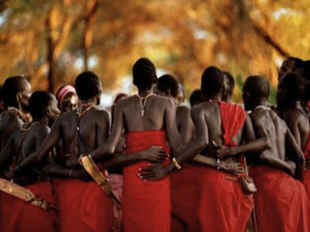
“In the Babemba tribe of Southern Africa, when a person acts irresponsibly or unjustly, he is placed in the centre of the village, alone and unfettered. All work ceases, and every man, woman, and child in the village gathers in a large circle around the accused individual.
Then, each person in the tribe speaks to the accused, one at a time, each recalling the good things the person in the centre of the circle has done in his lifetime. Every incident, every experience that can be recalled with any detail and accuracy, is recounted. All his positive attributes, good deeds, strengths, and kindnesses are recited carefully and at length.
This tribal ceremony often lasts for several days. At the end, the tribal circle is broken, a joyous celebration takes place, and the person is symbolically and literally welcomed back into the tribe.”
~Leonard Zunin~

