**Source:**

<http://louisville.edu/anthropology/undergraduate/what-is-anthropology>

[](http://louisville.edu/)

Top of Form

Bottom of Form

**[Department of Anthropology](http://louisville.edu/anthropology)**

**What is Anthropology?**

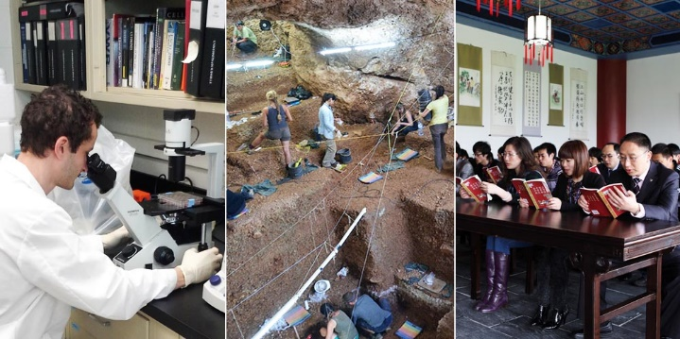

**Anthropology is the study of what it means to be human: from the study of culture and social relations, to human biology and evolution, to languages, to music, art and architecture, and to vestiges of human habitation.** It considers such fascinating questions as how peoples' behaviors change over time, how people move about the world, why and how people from distant parts of the world and dissimilar cultures are different and the same, how the human species has evolved over millions of years, and how individuals understand and operate successfully in distinct cultural settings.

**Anthropology includes four broad fields--*cultural anthropology*, *linguistics*, *physical anthropology* and *archaeology*.** Anthropologists are careful observers of humans and their behavior, maintaining an intense curiosity: What does it mean to be human? Why do people behave in particular ways? What are the historical and environmental pressures that helped shape the experience and behavior of a specific group of people? What are universal facts of human life?

============================================================

Branches of Anthropology:

* **Archaeology** - the study of the human past from an anthropological perspective.
* **Biological or physical anthropology** - the study of human populations from an evolutionary standpoint.
* **Cultural or social anthropology** - the differing cultures of human populations.