**Syllabus on International Economic Organisations and Climate Change**

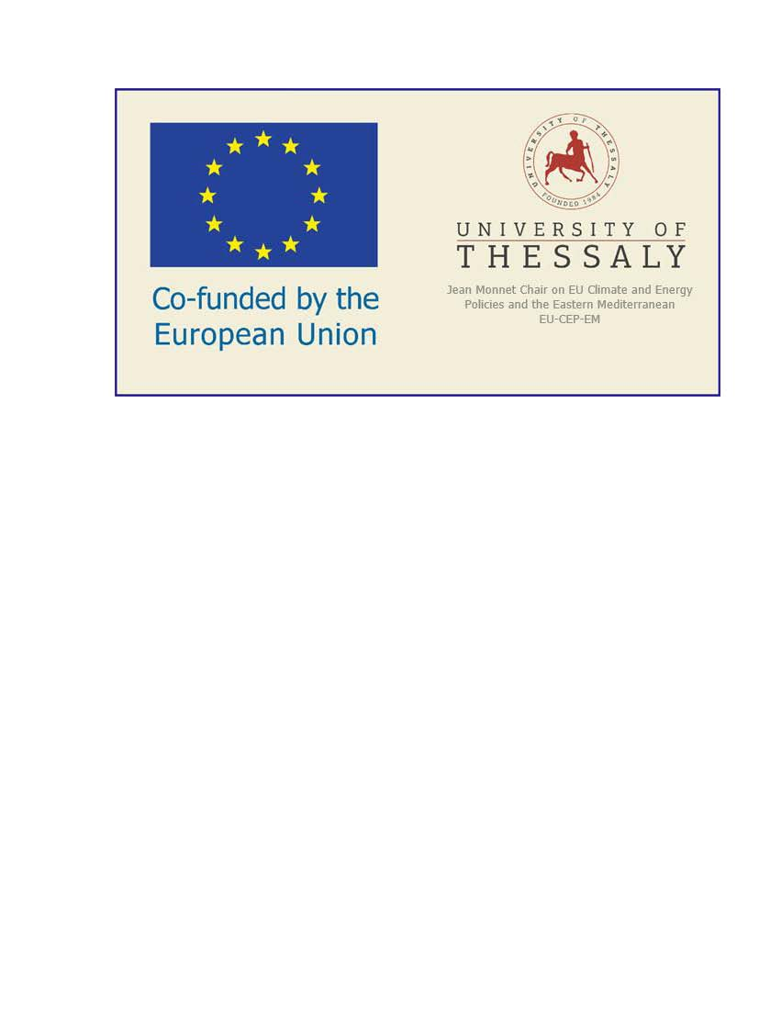**GENERAL**

|  |  |  |  |  |  |
| --- | --- | --- | --- | --- | --- |
| **SCHOOL** | School of Economics and Business Administration | | | | |
| **ACADEMIC UNIT** | Department of Economics | | | | |
| **LEVEL OF STUDIES** | Undergraduate | | | | |
| **COURSE CODE** | ΟΑ0108 | **SEMESTER** | | 4th | |
| **COURSE TITLE** | International Economic Organisations and Climate Change | | | | |
| **INDEPENDENT TEACHING ACTIVITIES** *if credits are awarded for separate components of the course, e.g. lectures, laboratory exercises, etc. If the credits are awarded for the whole of the course, give the weekly teaching hours and the total credits* | | | **WEEKLY TEACHING HOURS** | | **CREDITS** |
|  | | | 3 | | 4 |
| *Add rows if necessary. The organisation of teaching and the teaching methods used are described in detail at (d).* | | |  | |  |
| **COURSE TYPE**  *general background,  special background, specialised general knowledge, skills development* | general background, special background, specialised general knowledge | | | | |
| **PREREQUISITE COURSES:** | Non | | | | |
| **LANGUAGE OF INSTRUCTION and EXAMINATIONS:** | Greek | | | | |
| **IS THE COURSE OFFERED TO ERASMUS STUDENTS** | Yes | | | | |
| **COURSE WEBSITE (URL)** | https://eclass.uth.gr/courses/ECON_U_253/ | | | | |

**LEARNING OUTCOMES**

|  |  |
| --- | --- |
| **Learning outcomes** | |
| *The course learning outcomes, specific knowledge, skills and competences of an appropriate level, which the students will acquire with the successful completion of the course are described.*  *Consult Appendix A*   * *Description of the level of learning outcomes for each qualifications cycle, according to the Qualifications Framework of the European Higher Education Area* * *Descriptors for Levels 6, 7 & 8 of the European Qualifications Framework for Lifelong Learning and Appendix B* * *Guidelines for writing Learning Outcomes* | |
| **This course analyses a particular field of international economic relations. Upon successful completion of the course, the student will be able to:**  **Identify the architecture of the international economic system**  **Analyze the actors of international economic relations and their relationship to new environmental challenges**  **Understand how international economic processes and phenomena function and emerge**  **Understand Climate Change especially since the Mediterranean in particular is recognised as a climate change and biodiversity “hotspot”, with significant risks associated with the preservation of its unique flora and fauna, as well as its rich cultural heritage and agricultural traditions**  **Understand the necessity of cooperation between governments as a means to mitigate and adapt to the compounding challenges of the climate emergency.** | |
| **General Competences** | |
| *Taking into consideration the general competences that the degree-holder must acquire (as these appear in the Diploma Supplement and appear below), at which of the following does the course aim?* | |
| *Search for, analysis and synthesis of data and information, with the use of the necessary technology*  *Adapting to new situations*  *Decision-making*  *Working independently*  *Team work*  *Working in an international environment*  *Working in an interdisciplinary environment*  *Production of new research ideas* | *Project planning and management*  *Respect for difference and multiculturalism*  *Respect for the natural environment*  *Showing social, professional and ethical responsibility and sensitivity to gender issues*  *Criticism and self-criticism*  *Production of free, creative and inductive thinking*  *……*  *Others…*  *…….* |
| Adapting to new situations  Decision-making  Working independently  Team work  Working in an international environment  Working in an interdisciplinary environment  Production of new research ideas  Respect for difference and multiculturalism  Respect for the natural environment  Showing social, professional and ethical responsibility and sensitivity to gender issues  Criticism and self-criticism  Production of free, creative and inductive thinking | |

**SYLLABUS**

|  |
| --- |
| **1th session**: Introduction to the topic and the modalities of the course (methodology, evaluation, readings).  **2th session:** International Economic Organisations: The lecture aims at illuminating the many functions and roles International Economic Organisations fulfil, their bodies, structure and interplay with states and other entities in the international system and how they respond to the new environmental challenges. Since there is no world government, or world empire, international organizations have been established by states to help address international problems, facilitating trade, and providing financial assistance to countries. In particular, the following functions of International Economic Organizations are analysed:  Financial Assistance: Providing loans and grants to developing countries for various projects aimed at economic development.  Trade Facilitation: Establishing rules and frameworks that govern international trade to ensure fair competition.  Economic Policy Guidance: Offeing expertise and policy advice to help countries improve their economic management.  Crisis Management: Assisting countries facing economic crises through financial support and policy recommendations.  **3th session**: International Political Economy: Ontology, Epistemology, Methodology. Distinct contribution of International Political Economy; International Political Economy focuses on who gets what, when, and how (unlike International Economics) while emphasizing the role of economic issues in global politics (unlike International Relations); International Political Economy responds to mutual neglect of International Economics and International Relations (synthesizes the effect of any kind of political authority on markets, and conversely, of market forces on states) and studies the interplay between states and markets, particularly how interests, institutions, and ideas shape policy outcomes and how the structure of the global economy feeds back onto these Variables.  **4th session:** Theoretical approaches to international organizations: The lecture touches upon the various theoretical approaches designed to advance the understanding of the nature, functions, and impacts of international organizations: Such key theoretical approaches are the Functionalist and Neofunctionalist Approaches emerged as ones of the earliest theories of international organization focusing on technical and non-political cooperation, which can lead to greater integration over time; Neofunctionalism built on this idea that Integration in one sector can lead to spillover effects, encouraging further integration in other areas; Realist and Neorealist Perspectives emphasising the primacy of state power and national interests in shaping International Organisations behaviour and outcomes; Liberal Institutionalism argues that International Organisations can facilitate cooperation among states by reducing transaction costs and providing information, thereby helping states overcome collective action problems and achieve mutually beneficial outcomes. Constructivist Approaches focus on the role of norms, ideas, and social interactions in shaping International Organisations behaviour and impact. Organizational Theory borrowed from management studies construe International Organisations as bureaucracies with their own internal dynamics and organizational cultures. Critical Theories Including Marxist and post-colonial theories put emphasis on the power structures underlying International Organisations and their role in perpetuating global inequalities.  **5th session: the Bretton Woods international economic System:** The class analyses themain characteristics and evolution of the international monetary and financial system from 1944 until today. In particular, it is examined how has the global trade regime evolved and how has the international monetary regime evolved? The lecture also discusses the “growing intensity, extensity, and velocity of worldwide economic interactions and interconnectedness, from trade, through production, and finance, to the North-South power disparities, colonial legacies and the various trajectories of globalisation. It finally discusses the current currency appreciation de-appreciation methods applied globally after the departure from the Gold standard money system in the early 1970s as well as prevalent role of the US dollar and the current competition between national currencies.  **6th session. The International Monetary Fund (IMF):** In this session we are focusing to the evolution of the IMF since its founding and its Governance (especially to the quota system where each member's financial contribution determines its voting power within the organisation) and its Structure. Then we turn to the key functions of the IMF:  Economic Surveillance over its member countries to ensure stability in the global economy.  Financial Assistance: providing loans to countries facing balance-of-payments problems usually linked to specific economic reforms these countries have to implement.  Capacity Development by offering technical assistance and training to help member countries improve their economic management capabilities, thereby enhancing their ability to formulate effective policies.  We finally examine the main criticisms of the IMF's policies IMF's ability to adapt its strategies remains crucial for maintaining financial stability and fostering sustainable growth among its member nations and especially the developing countries  **7th session: The World Bank Group and multilateral development financing**: In this session we touch upon the World Bank Group and regional development banks that notably play crucial roles in multilateral development financing, aiming to alleviate poverty and promote sustainable economic growth in developing countries by highlighting their functions, collaborative efforts, the significance of their financial products as well as their financing mechanisms engulfing low-interest loans, zero to low-interest credits, and grants aimed at various sectors such as education, health, infrastructure, and environmental management.  Study topics are the components of the World Bank Group:  The International Bank for Reconstruction and Development Providing loans to middle-income and creditworthy low-income countries.  The International Development Association primarily offering concessional loans and grants to the poorest countries.  The International Finance Corporation overwhelmingly focusing on private sector development through investment and advisory services.  The Multilateral Investment Guarantee Agency designed to provide political risk insurance and credit enhancement to encourage foreign investment.  The International Centre for Settlement of Investment Disputes planned to facilitate the arbitration and conciliation of investment disputes.  **8th session: The international trading system: From GATT to the World Trade Organisation (WTO):** This session centres on the evolution of the international trading system from the General Agreement on Tariffs and Trade (GATT) to the World Trade Organization (WTO), i.e. from a legal agreement to an international organization with greater authority and capacity to enforce trade agreements among its 164 member countries as well as the changing dynamics of international trade and the complexities of global economic interactions. It further analyses the key principles of GATT/WTO that govern international trade:  Most-Favoured-Nation Principle  National Treatment  Reciprocity  Binding Tariffs  Special and Differential Treatment  **9th session: The Organization for economic Cooperation and Development (OECD):** This session concerns the OECD multifaceted organisation and the wide range of economic issues it deal with. This includes cross-country comparisons and country-specific evaluations that help policymakers understand economic trends and the impacts of various policies; its major reports and country surveys annually, along with billions of data points, which inform policy debates in parliaments, media, and research work. Then, it turns to the international standards the organisation has established in various areas, including anti-corruption measures Investment policies Corporate governance, Free movement of capital and goods, climate change, digital taxation, international tax policies, sustainable development, Improving education systems and tries to make the students understand how the organisation endeavours to achieve its main objectives:  Achieving sustainable economic growth and employment  Raising living standards in member countries  Maintaining financial stability  Assisting other countries' economic development  Contributing to growth in world trade  **10th session: The International Energy Agency** (IEA)**:** This session centres on the IEA and the significant role it plays in global efforts to reduce carbon emissions through various initiatives, strategies, and collaborations aimed at transforming the energy sector. In particular, we discuss:  **-** its Net Zero Roadmap a comprehensive strategy for achieving net-zero emissions in the energy sector by 2050, which is essential for limiting global warming to 1.5 °C as per the Paris Agreement.  - its Renewable Energy and Efficiency guidelines with a view of delivering over 80% of the emissions reductions needed by 2030.  - its International Collaboration initiatives designed to promote synergies to accelerate clean energy transitions and partnerships with other international organisations  - its Industry Emissions Reduction strategy in the framework of which the IEA has developed specific roadmaps for high-emission sectors such as oil and gas, recommending immediate actions to halve emissions intensity by 2030.  - its Support for Policy Development strategy aimed at offering assistance to governments in formulating effective climate policies.  **11th session:** **Climate Change**: Aim of the session is to make apprehensible that climate change represents a direct and multidimensional threat to humanity as a whole, with its cascading effects on daily life, access to resources, food security and the nature of multilateral relations. Climate refugees and migration, linked to environmental disasters and extreme weather events, such as floods, heatwaves and wildfires – which are only expected to increase in the future – are compounding these threats to state and societal resilience stemming from the current climate emergency. The session analyses the causes of Climate Change (Human Activities and natural factors), the consequences of climate change (rising Temperatures, extreme weather events, melting Ice and rising Sea Levels, Impact on Biodiversity and on global health) as well as the global responses to them.  **12th session: The Intergovernmental Panel on Climate Change and the role of the United Nations in containing the climate change.:** This session is dedicated to the analysis of the significance of this international panel of scientists and researchers that provide advice on climate change to the international community since it was established in 1988 by the World Meteorological Organization and the United Nations Environment Programme. Study questions are: what is the impact of its Assessment Reports, how an objective source of information are they, does it fulfil Its role to assess on a comprehensive, open, and transparent basis the latest scientific, technical, and socio-economic literature produced worldwide, with a view to better understanding (1) the risks of anthropocentric climate change, (2) its observed and projected impacts, and (3) options for adaptation and mitigation. It also focuses on the huge migration waves caused by climate change, the United Nations are faced with.  **13th session:** **Climate Crisis in the Mediterranean:** The session touches upon the importance of climate change and its impact on economic and social life specifically in the Mediterranean region. The Mediterranean in particular is recognised as a climate change and biodiversity “hotspot”, with significant risks associated with the preservation of its unique flora and fauna, as well as its rich cultural heritage and agricultural traditions. The region is increasingly hit with devastating heatwaves = water shortages, loss of biodiversity and risks to food production. According to the IPCC’s Sixth Assessment Report, an increase of 10-20 days per year of maximum daily temperature exceeding 35°C, a typical, critical threshold for crop productivity and triggering analogous increase in agricultural, ecological and hydrological droughts is expected, by the mid-century in the Mediterranean areas. Streamflow droughts and fire weather conditions are projected to become more severe and persistent in the region. Mediterranean summer climate is affected by the South Asian summer monsoon through the monsoon-desert teleconnection. In future, rainfall is expected to increase not only over the South Asian area but also over the East Asian summer monsoon and equatorial Atlantic regions, affecting the Mediterranean climate in the future. What are the reasons and what are the means to mitigate and adapt to the compounding challenges of the climate emergency are also discussed. |

**TEACHING and LEARNING METHODS - EVALUATION**

|  |  |
| --- | --- |
| **DELIVERY** *Face-to-face, Distance learning, etc.* | The course is carried out on the basis of a combined face-to-face and Distance Learning method |
| **USE OF INFORMATION AND COMMUNICATIONS TECHNOLOGY** *Use of ICT in teaching, laboratory education, communication with students* | e-class and Microsoft Teams |
| |  |  |  |  |  |  |  |  |  |  |  |  |  |  |  |  |  |  |  |  |  |  |  | | --- | --- | --- | --- | --- | --- | --- | --- | --- | --- | --- | --- | --- | --- | --- | --- | --- | --- | --- | --- | --- | --- | --- | | **Workload distribution** | More specifically, the workload of the module is  analysed as follows:   |  |  |  | | --- | --- | --- | |  | **Activity** | **WORKLOAD**  **(HOURS)** | |  | Lectures | 39 | |  | Study at home | 80 | |  | Completion of assignments | 50 | |  | Preparation for the final exam | 39 | |  | Final Examination | 2 | |  | Total | 210 | | |  |
| **STUDENT PERFORMANCE EVALUATION**  *Description of the evaluation procedure*  *Language of evaluation, methods of evaluation, summative or conclusive, multiple choice questionnaires, short-answer questions, open-ended questions, problem solving, written work, essay/report, oral examination, public presentation, laboratory work, clinical examination of patient, art interpretation, other*  *Specifically-defined evaluation criteria are given, and if and where they are accessible to students.* | Written Exam at the end of the Semester  The Erasmus Students are evaluated on the basis of an essay they are called upon to write.  Greek  Yes, they are announced in the e-class |

**ATTACHED BIBLIOGRAPHY**

|  |
| --- |
| **Suggested bibliography (Books):**  Willem Molle, *Global Economic Institutions* (Routledge Studies in the Modern World Economy) 1st Edition. London and New York: Routledge, 2006.    Eric Brousseau (ed.), Jean-Michel Glachant (ed.), Jérôme Sgard (ed.), *The Oxford Handbook of Institutions of International Economic Governance and Market Regulation*. Oxford Handbooks, 2019.  *Comparative Renewables Policy Political, Organizational and European Fields*, Edited by Elin Lerum Boasson, Merethe Dotterud Leiren and Jørgen Wettestad, London and New York: Routledge 2021.  Andreas Stergiou and Marika Karagianni, *Does Energy Cause Ethnic War? East Mediterranean and Caspian Sea Natural Gas and Regional Conflicts* (Newcastle upon Tyne – United Kingdom: Cambridge Scholars Publishing, 2019).  **Related academic journal articles and book chapters:**  Abbott, K.W. and Snidal, D. (1998). Why states act through formal international organizations, *Journal of Conflict Resolution*, 42(1), pp.3-32  Nielson, D. and Tierney, M. (2003). Delegation to international organizations: Agency theory and World Bank reform, *International Organization* 57(2): pp. 241-276.  Simmons, B.A. (2000). The legalization of international monetary affairs. *International Organization,* 54(3): pp. 573-602.  Woods, N. (2010). Global governance after the financial crisis: a new multilateralism or the last gasp of the great powers? *Global Policy* 1(1): pp. 51-63.  Andresen, S., & Hey, E. (2005). The effectiveness and legitimacy of international environmental institutions. International Environmental Agreements: Politics, *Law and Economics*, 5(3), 211-226.  Parker, C.F., Karlsson, C. and Hjerpe, M. (2015). Climate change leaders and followers: Leadership recognition and selection in the UNFCCC negotiations. *International Relations*, 29(4), pp. 434-454.  Andreas Stergiou, Socioeconomic and environmental impact of exploitation of hydrocarbons in maritime areas: The case of Greece. *Resour Environ Econ*, 2022, 4(1): 333-342. |