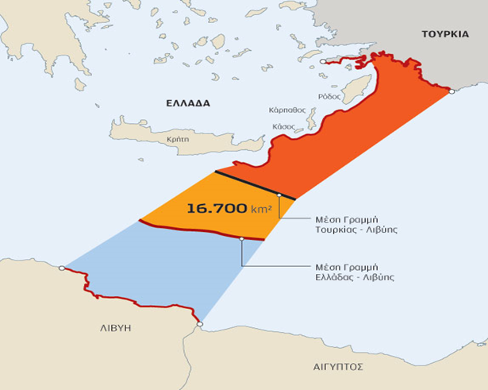
Figure No : Libyan – Turkish Maritime Boundaries according to Libyan-Turkey 2019 agreement. http://blogs.plymouth.ac.uk/dcss/2018/11/21/turkish-claims-in-east-med-unveiled-in-maps/.

