UNIT 37 Museums

WARM-UP EXERCISE.

- Before any museums were established, how did people get to be informed about artifacts or places of antiquity?
- To your knowledge, approximately when were museums built for the public to visit?
- Are all artifacts displayed in museums as soon as they are discovered? What is the process?
- Do all artifacts, discovered in archaeological sites, end up in museums? If not, where do they go?

NOTES.
……………………………………………………………………………………………………………………………………………………………………………………………………………………………………………………………………………………………………………………………………………………………………………………………………………………………………………………………………………………………………………………………………………………………………………………………………………………………………………………………………………………………………………………………………………………………………………………………………………………………………………………………………………………………………………………………………………………………………………………………………………………………………………………………………………………………………………………………………………………………………………………………………………………………………………………………………………...………………………………………………………………………………………………………………………………………………………………………………………………………………………………………………………………………………………………………………………………………………………………………………………………………………………………………………………………………………………………………………………………………………………………………………………………………………………………………………………………………………………………………………………………………………………………………………………………………………………………………………………………………………………………………………………………………………………………………………………………………………………………………………………………………………………………………………………………………………………………………………………………………………………………………………………………………………………………………………………………………………………………………………………………………………………………………………………………………………………………………………………………………………………………………………………………………………………………………………………………………………………………………………………………………………………………………………………………………………………………………………………………………………………………………………………………………………………………………………………………………………………………………………………………………………………………………………………………………………………………………………………………………………………………………………………………………………………………………………………………………………………………………………
NAVIGATION. KEY TERMS. Study the words prior to reading the text.
exhibit: to publicly display a valuable artifact or object of interest in a museum, art gallery or trade fair
exhibition: a public display of objects of interest, presentation
curate something: to take charge of (a museum); carefully choose, arrange, and present different items in an exhibition; to be a curator of (a museum)
curation: the action or process of selecting, organizing, and looking after the items in a collection or exhibition
curator: a keeper or custodian of a museum or other collection
select: carefully choose something/ someone as the best or most suitable
select: (adj.) first-rate, first-class, carefully chosen from a larger number as being the best or most valuable (among things or a group of people)
selection: the action of choosing the best or most suitable or most valuable
maritime: connected with the sea, especially in relation to seaborne trade or naval matters
seaborne: transported or travelling by sea

READING Museums

Origin of the word “Museum”
‘Museum’ is an ancient Greek word (μουσεῖον), dating back to the 5th century BC, but its present-day meaning is a foreign loan. More specifically, the word derives from μοῦσα (Muse), which initially signified “the place, which is dedicated to the Muses and the arts they represent” (cf. Plato, Phaedrus 278b.8-9: καταβάντες ἐς τό Νυμφῶν νᾶμά τε καί μουσεῖον ἠκούσαμεν λόγων). In the Hellenistic era, the word meant “philosophical school or library” (cf. Strabo, Geographica, 17.1).
Through the use of the Latin form ‘Museum’ and a number of changes of the concept ‘museum’ through the years, the meaning of the Greek word μουσεῖον (mouseion) came to pass as it is used today, i.e., a place, whether a building or a space outside, in which objects of historical, scientific, artistic, or cultural interest are stored and exhibited.
A Brief History of Museums
The history of Museums goes a long way back in time. Early in the 3rd century BCE, the great Museum at Alexandria, founded by Ptolemy I Soter, was more a prototype university, rather than an institution to preserve and interpret material aspects of one’s heritage. In 15th-century Europe, the revived term museum conveyed the concept of comprehensiveness rather than denoting a building. By the 17th century, museum was used in Europe to describe collections of curiosities, as the objects were called. In the 19th and 20th centuries, the word alluded to buildings housing, storing, preserving, interpreting and exhibiting objects of one’s cultural heritage.
Kinds of Museums
All over the world, there are museums, whether they are buildings housing artifacts of one’s cultural heritage, or open-air museums, where artifacts of great national or international value are preserved and displayed for people to see out in the open air. Also, there are underwater museums.
Among the numerous museums, where artifacts are displayed inside the buildings are the Archaeological Museum of Termez in modern Uzbekistan, the new Grand Egyptian Museum (GEM) in Giza outside Cairo, the Pergamon Museum in Berlin, the Louvre in Paris, the British Museum in London, the National Museum of Anthropology in Mexico City, or the Shi Huang Terracotta Warriors and Horses Museum in Xi'an, China, to name but a few.
Some of the open-air museums in the world are the Lake Dwelling Museum Unteruhldingen, in Muehlhoffen, Germany, where a sunken Stone Age village is revealed, or the Scottish Crannog Centre, at Loch Tay, in Perthshire, Scotland and countless other archaeological sites of great interest, such as those in Bergama, Ephesus, Miletus or ancient Knidos in Asia Minor (western Turkey), Abu Simbel, Luxor and Karnak in Egypt, Petra in Jordan, or Stonehenge in England.
Among those, which display artefacts both in the open air as well as in buildings, is the Tibes Indigenous Ceremonial Center in Puerto Rico, in the Antilles, a museum of particular interest. Across the seas, in Greece, there is the beautiful site in Delphoi with the temple of Apollo, the theatre, the stadium, and the Castalian Spring, while the Archaeological Museum exhibits the history of the Delphic sanctuary.
The Acropolis and the Acropolis Museum in Athens is of the most important ones in the world, as is the unique Multicentered Museum of Aigai in Central Macedonia, Greece, with a number of different exhibition places, both indoor and outdoor, gathered in one larger location. This museum includes the archaeological site with the restored Palace of Alexander the Great’s father, Philipp II of Macedon, constructed during his reign (359-336 BC), the Tomb of Philip II, the Royal Necropolis, and the Central Museum Building.

Among the renowned Underwater Museums in the world are the Caesarea Underwater Archaeological Park in Israel, the Underwater Archaeological Park of Baia in Italy, and the Peristera shipwreck in the Marine Park of Alonnisos, Northern Sporades, which opened as the first Underwater Museum in Greece in the recent years. As regards visiting one such museum, one would have to be familiar with scuba diving or snorkeling, or use a glass-bottom boat, to see the long-lost man-made creations or to admire the wonders of a natural monument below the surface of the water. Needless to say, it all depends on the depth of the water, the weather and environmental conditions.

Interestingly, also the kinds of artifacts exhibited specify different types of museums. Hence, there are: Archaeology Museums, Anthropology Museums, History Museums, Living History Museums, Natural Science Museums, Maritime Museums, Underwater Museums, Museums of Art in Nature, Museum of Musical Instruments, Science and Technology Museums, Art Museums, Astronomy Museums, Ecomuseums, Sports Museums, et al.
Mention of Interactive Museums worldwide is also a must, where efforts to engage school children as well as adults are made by using interactive exhibits and activities. Interactive museum experiences can enhance one’s learning by having fun. Examples of such museums are: the ArtScience Museum Singapore, Spyscape New York, the National Museum of Singapore, Exploratorium–San Francisco, the Museum of Childhood in London, the Quake: Lisbon Earthquake Museum in Portugal, and the Hong Kong Space Museum.
Nowadays, technology is ubiquitous; thus, by using a digital device, one can also visit a museum online, to be informed of its organization as well as the artifacts exhibited therein.

In contrast to all of the above is a different kind of museum, the Dubai Museum of the Future, which prompts the visitor to envision a future world, rather than the world of the past.

TASKS.

Task 1. Answer the following questions.
You may need to conduct some research to satisfactorily answer Question Nr. 4.

- What kinds of museums are there according to the artifacts’ exhibition place?
- What kinds of museums are there according to the kinds of artifacts displayed?
- What do you think is the best way that enables one to see the artifacts displayed in an Underwater Museum?
- What factors should one take into account prior to diving into the water in an Underwater Museum?

Task 2. Study. Contemplate. Write down your ideas and emotions.

You visit the Acropolis Museum in Athens. You stop, in order to look at a replica of the statue of Kouros/Kore with that characteristic smile on his/her face. Consider:

(a) What it might feel like, if you were a member of the Athenian society in the fifth- century B.C.
(b) If the community in the area where you live today would be happier, if people walking in the street had a pleasant countenance.

Task 3. Team Work or Individual Work. Speaking.
Describe a museum you have visited. Say:

- What kind of museum it is, and where it is.
- What types of artefacts are displayed.
- What the main purpose of your visit was.
- How you value your experience of that visit.
- If visiting that museum has influenced your decision concerning your career direction.

Task 4. Food for thought.

You have been asked to join a team of students from different parts of the world, who will be visiting your university. One of the tasks ascribed to you is a tour in the Archaeological - or Byzantine - Museum of your city. You will be the group-leader, so you need to organize the forthcoming event and prepare some material for your guests. The following questions may help you with your project.

Questions:

- Which Museum will you be taking your guests to?
- What will you include in your material and how will you make it available to them?
- In what language(s) will the museum tour be available?
- Will there be a guide to welcome you and your group and to show you round the museum?
- Does the museum have an application for smart portable devices for independent guided tours?
- Will there be some kind of aid for students who are hard-of-hearing or have some other ailment?
- Can you think of other things to take into consideration?

Task 5. World Heritage Sites or Monuments.
Read the following passage. Then, do some research on and talk about one World Heritage Monument that has made a deep impression on you, in class. (Duration: 15’ approximately).

There are some truly unique structures on our planet, declared to be World Heritage Sites or World Heritage Monuments. For example, the Uluru and Kata Tjuta National Park in the Australian outback, the Great Barrier Reef on the north-east coast of Australia; ancient Olympia in the Peloponnese, the Acropolis in Athens, Delos - “the most sacred of all islands” (Callimachus, 3rd century BC), or the Cave of the Apocalypse on the island of Patmos in Greece; the Painted Churches in the Troödos Region or the Khirokitia (sometimes spelled Choirokoitia; Gr., Χοιροκοιτία) an archaeological site, dating from the Neolithic age, on the island of Cyprus; the Minaret of Jam in Afghanistan, the Kasbah of Algiers, Los Glaciares National Park which is located in the Southwest of Santa Cruz Province in the Argentine part of Patagonia, the Lycian Myra Rock-Cut Tombs near Demre, Türkiye, or the Giants of Mont’e Prama, which is ‘a necropolis or monumental cemetery’ in Sardinia, Italy, et al. The list is endless.
Among the objects, which are not only valuable, but truly irreplaceable, and hence, rightly considered as monumental, is the Antikethyra Mechanism, which was first discovered by ‘sponge divers off Point Glyphadia on the Greek island of Antikythera in 1900’. It is an ancient Greek hand-powered orrery (model of the Solar System), described as the oldest known example of an analogue computer, used to predict astronomical positions and eclipses, decades in advance.

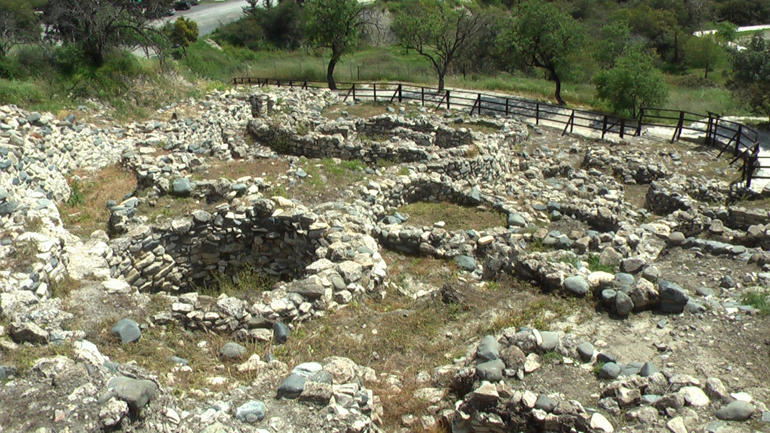
Picture: Choirokoitia. Houses from circa 6000 BC, located SW of Larnaka, Cyprus.
(By: Pan narrans. File:Choirokoitia 1.JPG. From Wikimedia Commons, the free media repository - https://upload.wikimedia.org/wikipedia/commons/5/56/Choirokoitia_1.JPG).

