UNIT 3 Submerged Continents

WARM-UP EXERCISE. What do you know about submerged continents? Discuss this with your instructor and fellow students in class.

NOTES.
………………………………………………………………………………………………………………………………………………………………………………………………………………………………………………………………………………………………………………………………………………………………………………………………………………………………………………………………………………………………………………………………………………………………………………………………………………………………………………………………………………………………………………………………………………………………………………………………………………………………………………………………………………………………………………………………………………………………………………………………………………………………………………………………………………………………………………………………………………………………………………………………………………………………………………………………………………………………………………………………………………………………………………………………………………………………………………………………………………………………………………………………………………………………………………………………………………………………………………………………………………………………………………………………………………………………………………………………………………………………………………………………………………………………………………………………………………………………………………………………………………………………………………………………………………………………………………………………………………………………………………………………………………………………………………………………………………………………………………………………………………………………………………………………………………………………………………………………………………………………………………………………………………………………………………………………………………………………………………………………………………………………………………………………………………………………………………………………………………………………………………………………………………………………………………………………………………………………………………………………………………………………………………………………………………………………………………………………………………………………………………………………………………………………………………………………………………………………

NAVIGATION. KEY TERMS. Study the following terms prior to reading the text.
continental shelf: a portion of a continent submerged under an area of relatively shallow water, known as a shelf sea
shelf sea: (geology) the part of a sea or ocean which is on a continental or insular shelf: an epicontinental sea
landmass (or, land mass): a large region or area of land that is in one piece and not broken up by oceans.
[See: Pangaea, Greece; Gondwana, New Zealand]
Gondwana (or, Gondwanaland): an ancient supercontinent that broke up about 180 million years ago and eventually split into what we recognize today as Africa, the Arabian Peninsula, the Indian subcontinent, South America, Australia and Antarctica. It was half of the Pangaea supercontinent, along with a northern supercontinent known as Laurasia.
yonder: (archaic) at some distance, over there

READING Submerged Continents

There are long-lost continents, cultures and civilizations, such as those of Atlantis or Kumari Kandam, which have been quite a mystery to geologists, anthropologists and archaeologists with regard to their existence. One thing in common is that they are said to have vanished below the surface of the sea after floods, earthquakes and/or volcanic eruptions.
Kumari Kandam is a mythical continent, generally assumed to be located south of present-day India in the Indian Ocean. Also known as Kumari Nadu or Lemuria, Kumari Kandam is a much older name, derived from the Sanskrit words “Kumarika Khanda”, and was first used in the 15th century Tamil source, the Skanda Purana, which is a collection of 18 Hindu religious texts, containing over 81,000 verses. Kumari Kandam is believed to be the birthplace of the Tamil civilization and the home of early literature. If it was submerged, it likely happened at the end of the last Ice Age, but it has yet to be proven.
Atlantis is an island empire (Ancient Greek: Ἀτλαντὶς νῆσος, literally, the 'island of Atlas'), mentioned in Plato's works Timaeus and Critias, which are the primary sources regarding Atlantis. Atlantis falls out of favor with the deities, in the end, and submerges into the Atlantic Ocean. It is believed to have existed about 9,000 years before Plato’s own time and to have vanished beneath the waves after a series of earthquakes and floods. Plato’s writings about Atlantis are the only known records of its existence. All other mentions of the empire of Atlantis are based on them. Plato introduced Atlantis in Timaeus, written in 360 BC:
“…. For the ocean there was at that time navigable; for in front of the mouth, which you Greeks call, as you say, 'the pillars of Heracles,' there lay an island which was larger than Libya and Asia together; and it was possible for the travelers of that time to cross from it to the other islands, and from the islands to the whole of the continent over against them, which encompasses that veritable ocean. For all that we have here, lying within the mouth of which we speak, is evidently a haven having a narrow entrance; but that yonder is a real ocean, and the land surrounding it may most rightly be called, in the fullest and truest sense, a continent. Now in this island of Atlantis there existed a confederation of kings, of great and marvelous power, which held sway over all the island, and over many other islands also and parts of the continent.”
Interestingly, scientists today keep looking for evidence that might prove these as well as other submerged continents’ existence. In fact, there has been made mention of Zealandia, a.k.a. Te Riu-a-Māui (Māori) or Tasmantis, and Mauritia, two submerged continents in the Pacific and Indian oceans respectively. Mauritia was a Precambrian microcontinent that was situated between India and Madagascar until their separation about 70 million years ago. Zealandia, a mass of continental crust in Oceania that subsided after breaking away from Gondwana 83–79 million years ago, may have been completely submerged beneath the Pacific Ocean by approximately 23 million years ago.
Submerged worlds, lost under the surface of the sea thousands or millions of years ago, have always intrigued people. When more details are discovered, we may be able to understand the history of our planet better.

TASKS.

Task 1. Answer the questions below in your own words.
- What are submerged continents?
- Is Kumari Kandam a real Indian continent that was forever lost under water?
- Was Atlantis real? What is your point of view?
- Why was Atlantis submerged under water?
- What is it that keeps people so intrigued about submerged continents?
- If we had substantial evidence about submerged continents and/or lost civilizations, do you think it would be important for the evolution of humanity?

Task 2. Creative Writing.
Write a paragraph, using the following words:

(1) culture; (2) submerged; (3) locate; (4) evidence; (5) islands; (6) flood

……………………………………………………………………………………………………………………………………………………………………………………………………………………………………………………………………………………………………………………………………………………………………………………………………………………………………………………………………………………………………………………………………………………………………………………………………………………………………………………………………………………………………………………………………………………………………………………………………………………………………………………………………………………………………………………………………………………………………………………………………………………………………………………………………………………………………………………………………………………………………………………………………………………………………………………………………………...………………………………………………………………………………………………………………………………………………………………………………………………………………………………………………………………………………………………………………………………………………………………………………………………………………………………………………………………………………………………………………………………………………………………………………………………………………………………………………………………………………………………………………………………………………………………………………………………………………………………………………………………………………………………………………

Task 3. Team Work or Individual Work.

(a) Use the internet to find and watch a short video of your choice on ‘submerged continents’. Make a note of the wording as well as the link you will use, to find the video. In this way, you will be able to retrieve it more easily.
(b) Make a note of the words you wish to remember.
(c) Make an oral or a written summary of the video.

Task 4. Mix and Match.
Match the meanings of the words in the two columns.
- variously a. immerse
- describe b. go down
- submerge c. retreat, withdraw
- fragment d. discover, expose
- subside e. delineate
- break away f. below, underneath
- beneath g. chip, piece
- uncover h. roughly, just about
- sink i. detach oneself
- approximately j. differently

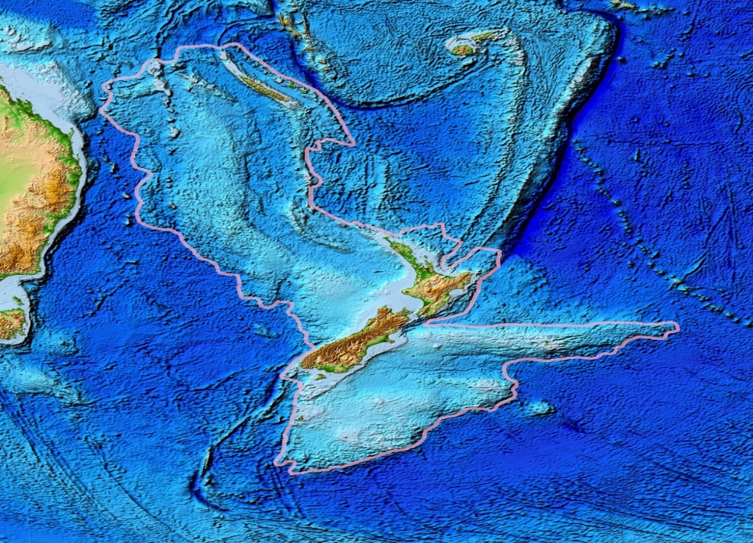

Picture: Topography of Zealandia, outlined in pink. (Public Domain. File: Zealandia topography.jpg).

Task 5. Find the synonyms and antonyms of the words in this group.

immerse, sink, submerge, submerse, ascend, neglect, dry, rise,

drench, absorb, engross, engage, involve, ignore

SYNONYMS: ………………………………………………………………………………………………………………………………………………………………………………………………………………………………………………………………………………………………………………………………………………………………………………………………………………………………………………………………………………………………………………………………………………

ANTONYMS:

………………………………………………………………………………………………………………………………………………………………………………………………………………………………………………………………………………………………………………………………………………………………………………………………………………………………………………………………………………………………………………………………………………

