Here's the latest on the UN Climate Conference

 | United Nations

Read this article on LinkedIn to join the conversation
Read on LinkedIn

With global temperatures hitting record highs, and extreme weather events affecting people around the globe, the COP29 climate conference is a critical opportunity to advance concrete solutions for the defining issue of our time.
Amid unprecedented climate challenges impacting people and communities all around the world, government, business and civil society leaders are meeting in Baku, Azerbaijan to accelerate climate action to protect people and our planet.
With trillions of dollars needed for countries to drastically reduce greenhouse gas emissions and address the worsening impacts of the climate emergency, finance will be a key area of focus throughout this conference.
“Climate finance is not charity, it’s an investment. Climate action is not optional, it’s an imperative,” United Nations Secretary-General António Guterres said during Tuesday’s World Leaders Climate Action Summit, urging leaders to deliver on climate action and finance to secure a liveable world and prosperous future for all.
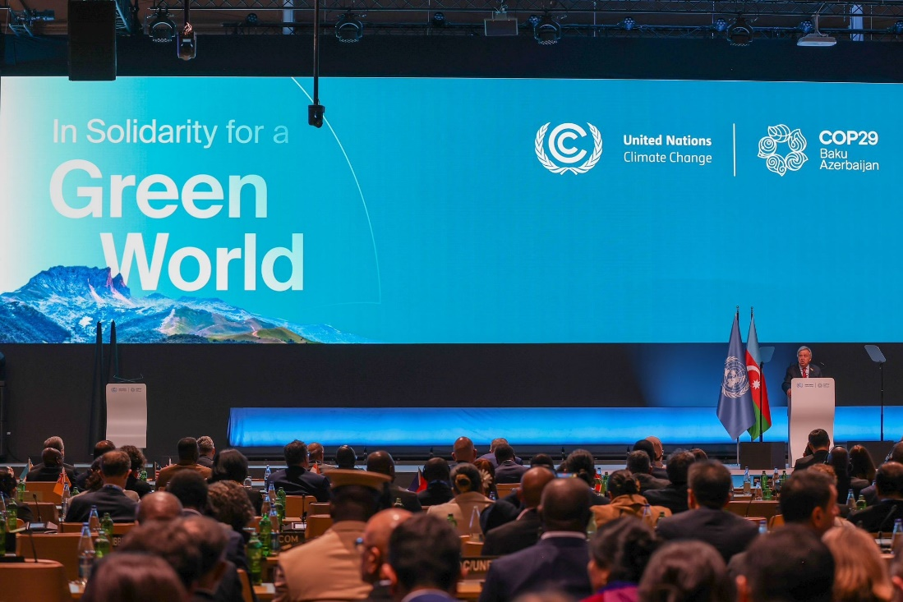UN Secretary-General António Guterres at COP29/Kiara Worth
He went on to stress that doubling down on fossil fuels is a failing proposition: “The clean energy revolution is here. No group, no business, and no government can stop it”.
“The sound you hear is the ticking clock. We are in the final countdown to limit global temperature rise to 1.5 degrees Celsius. And time is not on our side,” the Secretary-General warned.

The UN climate conference is scheduled to continue in Baku through 22 November. You can stay updated on the latest developments by following the UN’s page and gain further insights and perspectives from UN Secretary-General António Guterres’ LinkedIn account.
Join the conversation

