Source: https://www.britannica.com/animal/bee

Science Bugs, Mollusks & Other Invertebrates Insects
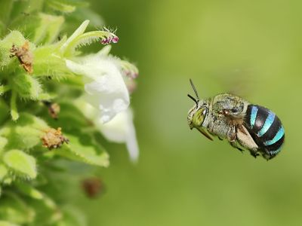
Solitary bee A blue-banded bee (Amegilla species) flying near a flower in Tamil Nadu, India.
bee
insect
Also known as: Apoidea
Written and fact-checked by

Last Updated: Dec 4, 2024 • Article History
Key People:
Karl von Frisch
Related Topics:
cuckoo bee
leaf-cutter bee
social bee
solitary bee
Stenotritidae
Top Questions

What is a bee?
What are the differences between bees and wasps?
Do male bees collect pollen?
bee, (superfamily Apoidea), any of more than 20,000 species of insects in the suborder Apocrita (order Hymenoptera), including the familiar honeybee (Apis) and bumblebee (Bombus) as well as thousands more wasplike and flylike bees. Adults range in size from about 2 mm to 4 cm (about 0.08–1.6 inches).
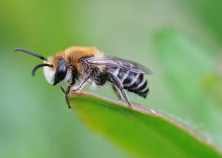
Plasterer bee Close-up of a plasterer bee (Colletes daviesanus).
Bees are closely related to certain types of wasps, the principal biological difference between them being that bees (except for parasitic cuckoo bees) provide their young with pollen and sometimes honey, whereas wasps feed their young animal food or provision their nests with insects or spiders. Associated with this difference in food preference are certain structural differences, the most essential being that wasps are covered with unbranched hairs, whereas bees have at least a few branched or feathered hairs to which pollen often clings.
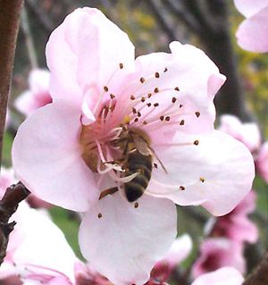
1 of 3
Nectar A honeybee (Apis) drinking nectar from a flower.
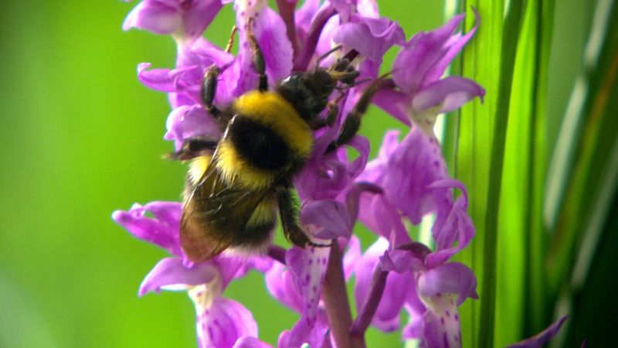
2 of 3

Roles of bees and flowers in European woodlands. Learn about ecological relationships between bees and various woodland flowers. Plant-pollinator interactions are not always mutually beneficial and can include nectar-robbing and deception.

See all videos for this article
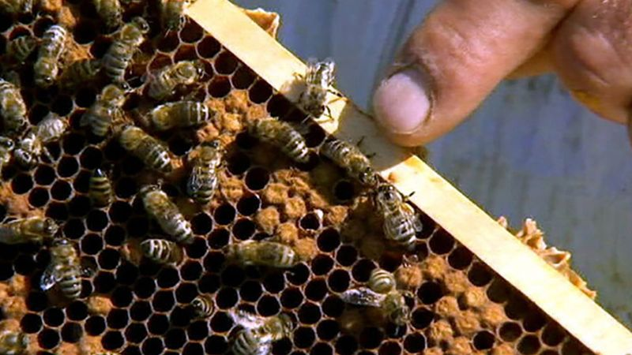
3 of 3

How do bees make honey? Overview of how honeybees produce honey.
See all videos for this article
Bees are entirely dependent on flowers for food, which consists of pollen and nectar, the latter sometimes modified and stored as honey. There is no doubt that bees and the flowers that they pollinate evolved simultaneously. As bees go from flower to flower gathering pollen, a small amount is rubbed from their bodies and deposited on the flowers they visit. This loss of pollen is significant, for it often results in cross-pollination of plants. The practical value of bees as pollinators is enormously greater than the value of the honey and wax of honeybees and stingless bees.

Britannica Quiz
Deadliest Animals Quiz

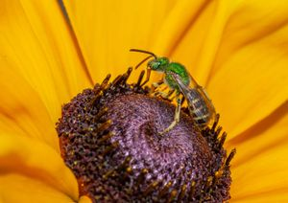
Sweat bee Bicolored striped sweat bee (Agapostemon virescens) foraging on a coneflower.
Male bees are usually short-lived and never collect pollen, nor do they have other responsibilities in connection with providing for the young. Female bees do all the work of nest making and provisioning and usually have special anatomical structures that assist them in carrying pollen. Most bees are polylectic, meaning that they gather pollen from a wide variety of flowers. However, some bees collect pollen only from flowers of certain families, others from flowers of certain colors. Oligolectic bees gather pollen from only a few related kinds of flowers. The mouth parts of bees, like the pollen-collecting and pollen-carrying devices, seem to be adapted to different flowers.
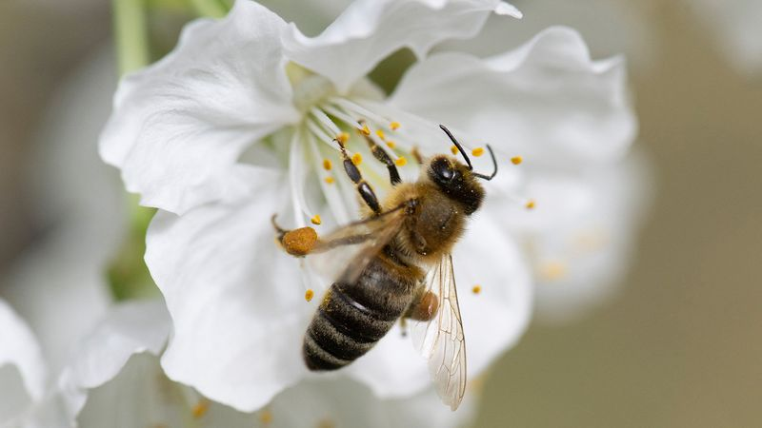
1 of 2

Which bee species really need saving? Learn about which of 20,000 species of bees are at risk of extinction.
See all videos for this article
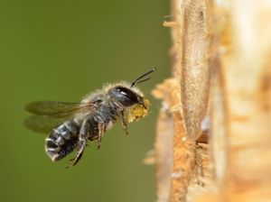
2 of 2

Blue mason bee Female blue mason bee (Osmia caerulescens) flying into an insect box in a garden, carrying leaf mastic (chewed leaf sections) to seal nest cells.
Most bees are solitary, or nonsocial, in habit and do not live in colonies. In these species each female makes her own nest (usually a burrow in the ground) and provisions it. Among such bees there are no castes. Some solitary bees make chimneys or turrets at the nest entrance, others nest in wood or in the pith of twigs or canes. Most solitary bees are short-lived as adults. Some species may be in flight only a few weeks of the year, having spent the rest of the year in their cells as eggs, larvae, pupae, and young adults.
Solitary bees provide all of the food the larvae require to complete development when the cells are sealed. Social bees, such as the bumblebee and the honeybee, feed their young progressively. For the life cycle of social bees, see bumblebee; honeybee; stingless bee.

Get Unlimited Access
Try Britannica Premium for free and discover more.
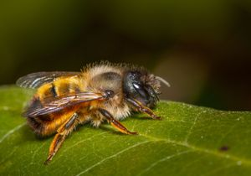
Red mason bee Close-up of a red mason bee (Osmia bicornis).
The Apoidea includes seven families: Colletidae, which are plasterer bees consisting of five or six subfamilies, about 45 genera, and some 2,500 species; Andrenidae, which are medium- and large-sized solitary mining bees, including some parasitic species; Halictidae, about 4,500 species of sweat bees, which are attracted to perspiration; Melittidae, bees that mark a transitional form between the lower and the higher bees; Megachilidae (leaf-cutting and mason bees), noted for their elaborate nest structures; Stenotritidae, a small family of Australian bees; and Apidae with some 5,700 species of bumblebees, honeybees, stingless bees, carpenter bees, and digger bees.
The Editors of Encyclopaedia BritannicaThis article was most recently revised and updated by Melissa Petruzzello.
pollination
Table of Contents
- Introduction

• Types: self-pollination and cross-pollination
• Evolution of insect pollination
- •
Agents of pollen dispersal
References & Edit History Related Topics
Images & Videos
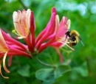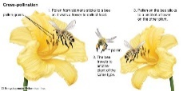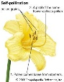
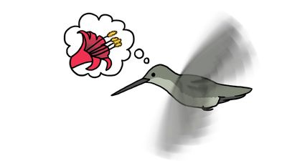

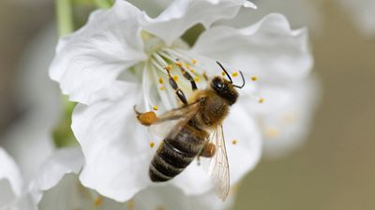

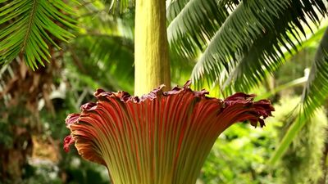

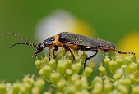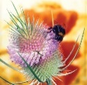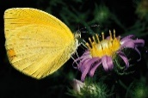
For Students
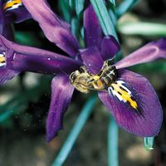
pollination summary
Read Next
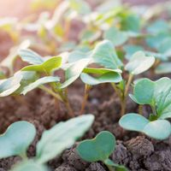
Do Plants Feel Pain?
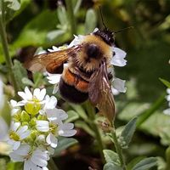
What Would Happen If All the Bees Died?
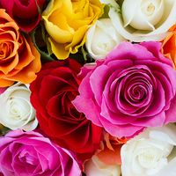
Do Plants Have Sexes?
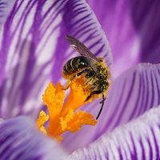
5 Fast Facts About Flower Anatomy
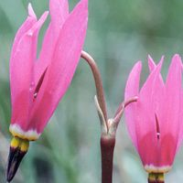
Botanical Sex: 9 Alluring Adaptations
Discover
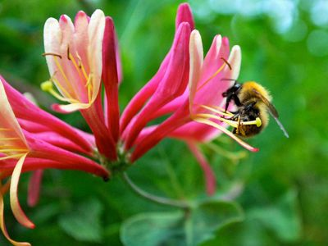
Bumblebee on honeysuckle Common carder bumblebee (Bombus pascuorum) pollinating a honeysuckle (Lonicera species) flower.
pollination
ecology
Written by

Fact-checked by

Last Updated: Dec 2, 2024 • Article History
Key People:
Prospero Alpini
Related Topics:
cross-pollination
buzz pollination
plunger pollination
chiropterophily
self-pollination
pollination, transfer of pollen grains from the stamens (the flower parts that produce them) to the ovule-bearing organs or to the ovules (seed precursors) themselves. In gymnosperm plants such as conifers and cycads, in which the ovules are exposed, the pollen is simply caught in a drop of fluid secreted by the ovule. In flowering plants, however, the ovules are contained within a hollow organ called the pistil, and the pollen is deposited on the pistil’s receptive surface, the stigma. There the pollen germinates and gives rise to a pollen tube, which grows down through the pistil toward one of the ovules in its base. In an act of double fertilization, one of the two sperm cells within the pollen tube fuses with the egg cell of the ovule, making possible the development of an embryo, and the other cell combines with the two subsidiary sexual nuclei of the ovule, which initiates formation of a reserve food tissue, the endosperm. The growing ovule then transforms itself into a seed.
As a prerequisite for fertilization, pollination is essential to the perpetuation of the vast majority of the world’s wild plants as well as to the production of most fruit and seed crops. It also plays an important part in programs designed to improve plants by breeding. Furthermore, studies of pollination are invaluable for understanding the evolution of flowering plants and their distribution in the world today. As sedentary organisms, plants usually must enlist the services of external agents for pollen transport. In flowering plants, these are (roughly in order of diminishing importance) insects, wind, birds, mammals, and water. See also major types of pollinators.
Types: self-pollination and cross-pollination
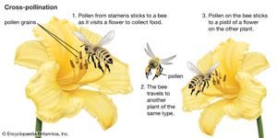
Cross-pollination The process of cross-pollination using an animal pollinator.
An egg cell in an ovule of a flower may be fertilized by a sperm cell derived from a pollen grain produced by that same flower or by another flower on the same plant, in either of which two cases fertilization is said to be due to self-pollination (autogamy); or, the sperm may be derived from pollen originating on a different plant individual, in which case the process is called cross-pollination (heterogamy). Both processes are common, but cross-pollination clearly has certain evolutionary advantages for the species: the seeds formed may combine the hereditary traits of both parents, and the resulting offspring generally are more varied than would be the case after self-pollination. In a changing environment, some of the individuals resulting from cross-pollination still may be found capable of coping with their new situation, ensuring survival of the species, whereas the individuals resulting from self-pollination might all be unable to adjust. Self-pollination, or selfing, although foolproof in a stable environment, thus is an evolutionary cul-de-sac. There also is a more direct, visible difference between selfing and outbreeding (cross-pollination): in those species where both methods work, cross-pollination usually produces more, and better quality, seeds. A dramatic demonstration of this effect is found with hybrid corn (maize), a superior product that results from cross-breeding of several especially bred lines.

