Source: https://www.britannica.com/topic/Greek-mythology/Types-of-myths-in-Greek-culture

Greek mythology
Last Updated: Mar 11, 2024 • Article History

MLA Style
Pollard, John Richard Thornhill and Adkins, A.W.H. "Greek mythology". Encyclopedia Britannica, 11 Mar. 2024, https://www.britannica.com/topic/Greek-mythology.
Accessed 20 March 2024.

APA Style
Pollard, J. Richard Thornhill and Adkins, A.W.H. (2024, March 11). Greek mythology. Encyclopedia Britannica. https://www.britannica.com/topic/Greek-mythology

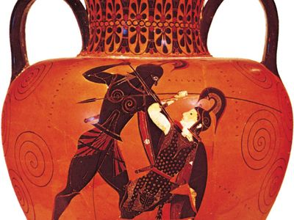
Exekias: Greek amphora depicting Achilles slaying Penthesilea

- Who are some of the major figures of Greek mythology?
- What are some major works in Greek mythology?
- When did Greek mythology start?
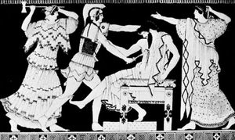
Electra and Orestes killing Aegisthus
Electra and Orestes killing Aegisthus in the presence of their mother, Clytemnestra;
detail of a Greek vase, 5th century bce.
Greek mythology, body of stories concerning the gods, heroes, and rituals of the ancient Greeks and Classical antiquity. That the myths contained a considerable element of fiction was recognized by the more critical Greeks, such as the philosopher Plato in the 5th–4th century bce. In general, however, in the popular piety of the Greeks, the myths were viewed as true accounts. Greek mythology has subsequently had extensive influence on the arts and literature of Western civilization, which fell heir to much of Greek culture.
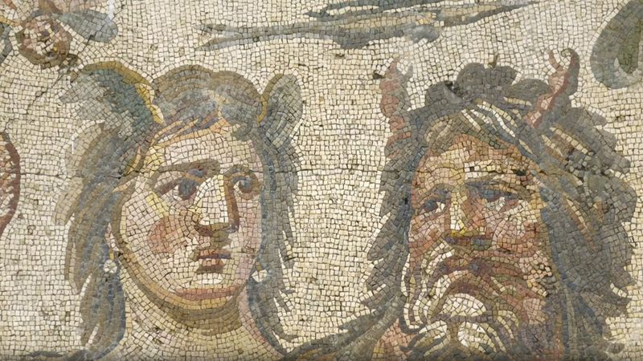

Learn more about the mythology, legends, and folktales of ancient Greece.
See all videos for this article
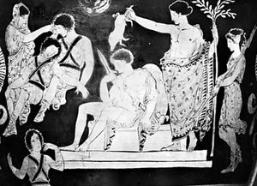
Orestes
Orestes being purified by Apollo after his acquittal by the court of the Areopagus, detail of a 5th-century-bce Greek vase; in the Louvre
Although people of all countries, eras, and stages of civilization have developed myths that explain the existence and workings of natural phenomena, recount the deeds of gods or heroes, or seek to justify social or political institutions, the myths of the Greeks have remained unrivaled in the Western world as sources of imaginative and appealing ideas. Poets and artists from ancient times to the present have derived inspiration from Greek mythology and have discovered contemporary significance and relevance in Classical mythological themes.

Sources of myths: literary and archaeological

The Homeric poems: the Iliad and the Odyssey

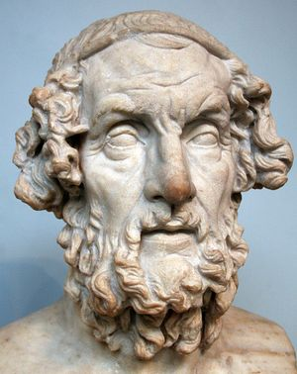
Homer
Homer, copy of a lost bust from the 2nd century from Baiae, Italy.
The 5th-century-bce Greek historian Herodotus remarked that Homer and Hesiod gave to the Olympian gods their familiar characteristics. Few today would accept this literally. In the first book of the Iliad, the son of Zeus and Leto (Apollo, line 9) is as instantly identifiable to the Greek reader by his patronymic as are the sons of Atreus (Agamemnon and Menelaus, line 16). In both cases, the audience is expected to have knowledge of the myths that preceded their literary rendering. Little is known to suggest that the Greeks treated Homer, or any other source of Greek myths, as mere entertainment, whereas there are prominent Greeks from Pindar to the later Stoa for whom myths, and those from Homer in particular, are so serious as to warrant bowdlerization or allegorization.
bowdlerization: expurgation by omission or modification - e.g., of parts of a book because they are considered vulgar.
allegorization: the act of turning into allegory, or of understanding in an allegorical sense.
stoa (plural, stoae or stoæ or stoai or stoas): in Ancient Greece, a walkway with a roof supported by colonnades, often with a wall on one side; specifically, the Great Hall in Athens.
Stoicism: is a school of Hellenistic philosophy that flourished in Ancient Greece and Ancient Rome. The Stoics believed that the practice of virtue is enough to achieve eudaimonia: a well-lived life.
warrant: justify or necessitate (a course of action) – e.g., "the employees feel that industrial action is warranted". // officially affirm or guarantee – e.g., "the vendor warrants the accuracy of the report".

theodicy: the question of how God can exist when there is evil in the world, or a good reason or explanation for this. Theodicy is the problem of how to reconcile a just God with a world containing evil.
harangue: tirade, a long and angry speech.
aetiological (or, etiological) myths: explain the reason why something is the way it is today. The word aetiological is from the Greek word aetion (αἴτιον), meaning “reason” or “explanation”. Note that the reasons given in an aetiological myth are not the real (or scientific) reasons.
c.: circa, approximately.
bce: before the common era // BCE: Before Christ’s Era. // ce: common era.

The works of Hesiod: Theogony and Works and Days

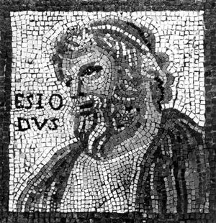Hesiod
Hesiod, detail of a mosaic by Monnus, 3rd century; in the Rhenish State Museum, Trier, Germany.
The fullest and most important source of myths about the origin of the gods is the Theogony of Hesiod (c. 700 bce). The elaborate genealogies mentioned above are accompanied by folktales and etiological myths. The Works and Days shares some of these in the context of a farmer’s calendar and an extensive harangue on the subject of justice addressed to Hesiod’s possibly fictitious brother Perses. The orthodox view treats the two poems as quite different in theme and treats the Works and Days as a theodicy (a natural theology). It is possible, however, to treat the two poems as a diptych, each part dependent on the other. The Theogony declares the identities and alliances of the gods, while the Works and Days gives advice on the best way to succeed in a dangerous world, and Hesiod urges that the most reliable—though by no means certain—way is to be just.

Other literary works
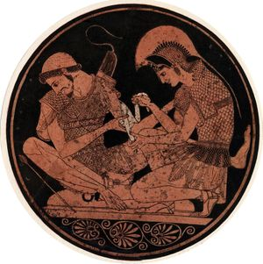
Achilles and Patroclus
Achilles bandaging Patroclus in a scene from Homer's Iliad.
Fragmentary post-Homeric epics of varying date and authorship filled the gaps in the accounts of the Trojan War recorded in the Iliad and Odyssey; the so-called Homeric Hymns (shorter surviving poems) are the source of several important religious myths. Many of the lyric poets preserved various myths, but the odes of Pindar of Thebes (flourished 6th–5th century bce) are particularly rich in myth and legend. The works of the three tragedians—Aeschylus, Sophocles, and Euripides, all of the 5th century bce—are remarkable for the variety of the traditions they preserve.
In Hellenistic times (323–30 bce) Callimachus, a 3rd-century-bce poet and scholar in Alexandria, recorded many obscure myths; his contemporary, the mythographer Euhemerus, suggested that the gods were originally human, a view known as Euhemerism. Apollonius of Rhodes, another scholar of the 3rd century bce, preserved the fullest account of the Argonauts in search of the Golden Fleece.
In the period of the Roman Empire, the Geography of Strabo (1st century bce), the Library of the pseudo-Apollodorus (attributed to a 2nd-century-ce scholar), the antiquarian writings of the Greek biographer Plutarch, and the works of Pausanias, a 2nd-century-ce historian, as well as the Latin Genealogies of Hyginus, a 2nd-century-ce mythographer, have provided valuable sources in Latin of later Greek mythology.

Source: https://www.britannica.com/biography/Euhemerus-Greek-mythographer
Cite as: Britannica, T. Editors of Encyclopaedia (2024, February 29). Euhemerus. Encyclopedia Britannica. https://www.britannica.com/biography/Euhemerus-Greek-mythographer
This article was most recently revised and updated by Encyclopaedia Britannica.

Euhemerus
Greek mythographer - Also known as: Euemeros, Evemerus
Last Updated: Feb 29, 2024 • Article History - Category: History & Society
Also spelled: Euemeros, or Evemerus
Flourished: c. 300 bc, Messene? [now Messina, Sicily, Italy]
Flourished: 300 BCE - Messina
Subjects Of Study: ancient Greece

Euhemerus (flourished c. 300 bc, Messene? [now Messina, Sicily, Italy]) was an author of a utopian work that was popular in the ancient world; his name was given to the theory that gods are great men worshipped after their death (i.e., Euhemerism). His most important work was Hiera Anagraphe (probably early 3rd century bc; “The Sacred Inscription”), which was translated into Latin by the poet Ennius (239–169 bc). Only fragments survive of both the original Greek and the Latin translation.
In Euhemerus’s first-person narrative, he is sent by the Macedonian king Cassander (305–297 bc) on an imaginary voyage to the Indian Ocean, where he eventually lands on an island he calls Panchaea. The island is full of marvels, and it has a clear three-class structure: priests and craftsmen, farmers, and soldiers and shepherds. On Panchaea the poet discovers in a temple of Zeus the sacred inscription that gives the book its name. The inscription explains that Zeus and his ancestors Uranus (Heaven) and the Titan Cronus, as well as the other gods, were mortals who were worshipped because of their accomplishments or merits. Euhemerus may have been simply applying to all the gods what was commonly believed to be true of some—e.g., Dionysus and Heracles. He may also have been influenced by Hellenistic ruler cults, which became popular as a result of the success of Alexander the Great.
Euhemerus’s work combined elements of fiction, political utopianism, and theology. In the ancient world he was considered an atheist. Early Christian writers, such as Lactantius, used the principles of Euhemerus to assert that, because the ancient gods were originally human, they were necessarily inferior to the Christian god.

Archaeological discoveries
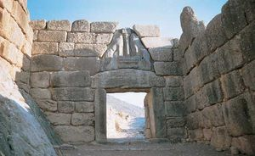
Lion Gate
The Lion Gate in Mycenae, Greece, constructed of stone, c. 1250 bce.
The discovery of the Mycenaean civilization by Heinrich Schliemann, a 19th-century German amateur archaeologist, and the discovery of the Minoan civilization in Crete (from which the Mycenaean ultimately derived) by Sir Arthur Evans, a 20th-century English archaeologist, are essential to the 21st-century understanding of the development of myth and ritual in the Greek world. Such discoveries illuminated aspects of Minoan culture from about 2200 to 1450 bce and Mycenaean culture from about 1600 to 1200 bce; those eras were followed by a Dark Age that lasted until about 800 bce. Unfortunately, the evidence about myth and ritual at Mycenaean and Minoan sites is entirely monumental, because the Linear B script (an ancient form of Greek found in both Crete and Greece) was mainly used to record inventories.
inventory: κατάλογος, απογραφή.
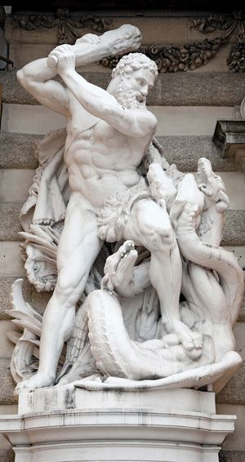
Heracles battling the Lernaean Hydra
Heracles (Hercules) battling the Lernaean Hydra; at the southern entrance to the Hofburg (Imperial Palace) in Vienna.
Geometric designs on pottery of the 8th century bce depict scenes from the Trojan cycle, as well as the adventures of Heracles. The extreme formality of the style, however, renders much of the identification difficult, and there is no inscriptional evidence accompanying the designs to assist scholars in identification and interpretation. In the succeeding Archaic (c. 750–c. 500 bce), Classical (c. 480–323 bce), and Hellenistic periods, Homeric and various other mythological scenes appear to supplement the existing literary evidence.

Forms of myth in Greek culture
To distinguish between myth, legend, and folktale can be useful, provided it is remembered that the Greeks themselves did not do so.

Religious myths
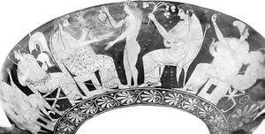
The gods on Olympus
The gods on Olympus: Athena, Zeus, Dionysus, Hera, and Aphrodite. Detail of a painting on a Greek cup; in the National Archaeological Museum, Tarquinia, Italy.
Greek religious myths are concerned with gods or heroes in their more serious aspects or are connected with ritual. They include cosmogonical tales of the genesis of the gods and the world out of Chaos, the successions of divine rulers, and the internecine struggles that culminated in the supremacy of Zeus, the ruling god of Olympus (the mountain that was considered the home of the gods). They also include the long tale of Zeus’s amours with goddesses and mortal women, which usually resulted in the births of younger deities and heroes. The goddess Athena’s unique status is implicit in the story of her motherless birth (she sprang full-grown from Zeus’s forehead); and the myths of Apollo explain that god’s sacral associations, describe his remarkable victories over monsters and giants, and stress his jealousy and the dangers inherent in immortal alliances.
internecine: destructive to both sides in a conflict.
implicit: implied, hinted, suggested though not directly expressed.
sacral: relating to sacred rites or symbols.
inherent: inborn, intrinsic, ingrained, existing in something as a permanent, essential, or characteristic attribute.
quasi: “resembling,” “having some, but not all of the features of,” used in the formation of compound words: quasi-definition; quasi-monopoly; quasi-official; quasi-scientific.
sack: the plundering of a captured place.
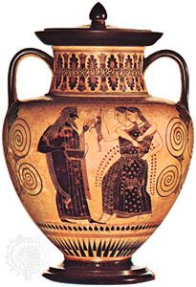
Dionysus and the Maenads
Dionysus and the Maenads, amphora by the Amasis Painter, c. 530 bce;
in the Cabinet des Médailles, Paris.
Myths of Dionysus, on the other hand, demonstrate the hostility aroused by a novel faith. Some myths are closely associated with rituals, such as the account of the drowning of the infant Zeus’s cries by the Curetes, attendants of Zeus, clashing their weapons, or Hera’s annual restoration of her virginity by bathing in the spring Canathus. Some myths about heroes and heroines also have a religious basis. The tale of creation and moral decline forms part of the myth of the Four Ages (see below Myths of the ages of the world). The subsequent destruction of humanity by flood and regeneration of humans from stones is partly based on folktale.
Curetes: In Greek mythology and epic literature, the Curetes (Ancient Greek: Κουρῆτες) were legendary people who took part in the quarrel over the Calydonian boar.^{[1]} Strabo mentioned that the Curetes were assigned multiple identities and places of origin (i.e. either Acarnanians, Aetolians, from Crete, or from Euboea). However, he clarified the identity of the Curetes and regarded them solely as Aetolians.^{[2]} Dionysius of Halicarnassus mentioned the Curetes as the old name of the Aetolians. ^{[3]}

Legends
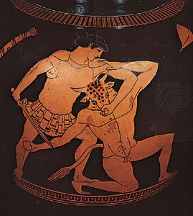
Theseus killing the Minotaur
Theseus killing the Minotaur, detail of a vase painting by the Kleophrades Painter, 6th century bce; in the British Museum, London.
Myths were viewed as embodying divine or timeless truths, whereas legends (or sagas) were quasi-historical. Hence, famous events in epics, such as the Trojan War, were generally regarded as having really happened, and heroes and heroines were believed to have actually lived. Earlier sagas, such as the voyage of the Argonauts, were accepted in a similar fashion. Most Greek legends were embellished with folktales and fiction, but some certainly contain a historical substratum. Such are the tales of more than one sack of Troy, which are supported by archaeological evidence, and the labours of Heracles, which might suggest Mycenaean feudalism. Again, the legend of the Minotaur (a being part human, part bull) could have arisen from exaggerated accounts of bull leaping in ancient Crete.
In another class of legends, heinous offenses—such as attempting to rape a goddess, deceiving the gods grossly by inculpating them in crime, or assuming their prerogatives—were punished by everlasting torture in the underworld. The consequences of social crimes, such as murder or incest, were also described in legend (e.g., the story of Oedipus, who killed his father and married his mother). Legends were also sometimes employed to justify existing political systems or to bolster territorial claims.

bolster: to support with or as if with a bolster; reinforce.

progeny: children, offspring.

trickster: swindler – κατεργάρης.

fissure: crack, split - ρωγμή, σχισμή.

don: put on – φοράω, βάζω.

Folktales
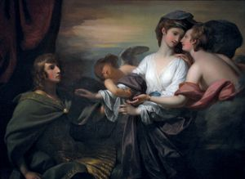
Benjamin West: Helen Brought to Paris
Helen Brought to Paris, oil on canvas by Benjamin West, 1776; in the Smithsonian American Art Museum, Washington, D.C. 143.3 × 198.3 cm.
Folktales, consisting of popular recurring themes and told for amusement, inevitably found their way into Greek myth. Such is the theme of lost persons—whether husband, wife, or child (e.g., Odysseus, Helen of Troy, or Paris of Troy)—found or recovered after long and exciting adventures. Journeys to the land of the dead were made by Orpheus (a hero who went to Hades to restore his dead wife, Eurydice, to the realm of the living), Heracles, Odysseus, and Theseus (the slayer of the Minotaur). The victory of the little man by means of cunning against impossible odds, the exploits of the superman (e.g., Heracles), or the long-delayed victory over enemies are still as popular with modern writers as they were with the Greeks.
The successful countering of the machinations of cruel sires and stepmothers, the rescue of princesses from monsters, and temporary forgetfulness at a crucial moment are also familiar themes in Greek myth. Recognition by tokens, such as peculiarities of dress or Odysseus’s scar, is another common folktale motif. The babes-in-the-woods theme of the exposure of children and their subsequent recovery is also found in Greek myth. The Greeks, however, also knew of the exposure of children as a common practice.

Types of myths in Greek culture

Myths of origin
Myths of origin represent an attempt to render the universe comprehensible in human terms. Greek creation myths (cosmogonies) and views of the universe (cosmologies) were more systematic and specific than those of other ancient peoples. Yet, their very artistry serves as an impediment to interpretation, since the Greeks embellished the myths with folktale and fiction told for its own sake. Thus, though the aim of Hesiod’s Theogony is to describe the ascendancy of Zeus (and, incidentally, the rise of the other gods), the inclusion of such familiar themes as the hostility between the generations, the enigma of woman (Pandora), the exploits of the friendly trickster (Prometheus), and the struggles against powerful beings or monsters like the Titans (and, in later tradition, the Giants) enhances the interest of an epic account.
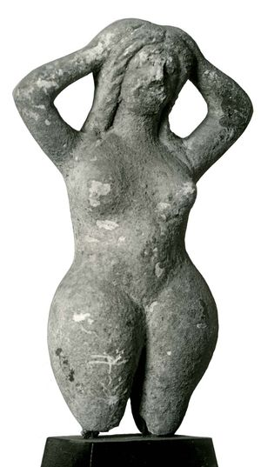
Gaea
Gaea, terra-cotta statuette from Tanagra, Greece; in the Musée Borély, Marseille.
According to Hesiod, four primary divine beings first came into existence: the Gap (Chaos), Earth (Gaea), the Abyss (Tartarus), and Love (Eros). The creative process began with the forcible separation of Gaea from her doting consort Heaven (Uranus) in order to allow her progeny to be born. The means of separation employed, the cutting off of Uranus’s genitals by his son Cronus, bears a certain resemblance to a similar story recorded in Babylonian epic. The crudity is relieved, however, in characteristic Greek fashion, by the friendly collaboration of Uranus and Gaea, after their divorce, on a plan to save Zeus from the same Cronus, his cannibalistic sire.
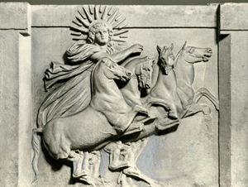
Helios
Helios in his chariot, relief sculpture excavated at Troy in 1872; in the National Museums in Berlin.
According to Greek cosmological concepts, the Earth was viewed as a flat disk afloat on the river of Ocean. The Sun (Helios) traversed the heavens like a charioteer and sailed around the Earth in a golden bowl at night. Natural fissures were popularly regarded as entrances to the subterranean house of Hades—i.e., the home of the dead.

Myths of the ages of the world
From a very early period, Greek myths seem to have been open to criticism and alteration on grounds of morality or of misrepresentation of known facts. In the Works and Days, Hesiod makes use of a scheme of Four Ages (or Races): Golden, Silver, Bronze, and Iron. “Race” is the more accurate translation, but “Golden Age” has become so established in English that both terms should be mentioned. These races or ages are separate creations of the gods, the Golden Age belonging to the reign of Cronus and the subsequent races being the creation of Zeus. Those of the Golden Age never grew old, were free from toil, and passed their time in jollity and feasting. When they died, they became guardian spirits on Earth.

Why the Golden Age came to an end Hesiod failed to explain, but it was succeeded by the Silver Age. After an inordinately prolonged childhood, the men of the Silver Age began to act presumptuously and neglected the gods. Consequently, Zeus hid them in the Earth, where they became spirits among the dead.
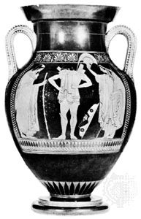
Euthymides: Hector donning his breastplate
Hector donning his breastplate, amphora by Euthymides, c. 500 bce; in the National Museum of Antiquities, Munich.
Zeus next created the men of the Bronze Age, men of violence who perished by mutual destruction. At this point the poet intercalates the Age (or Race) of Heroes. He thereby destroys the symmetry of the myth, in the interests of history: what is now known as the Minoan-Mycenaean period was generally believed in antiquity to have been a good time to live. (This subjection of myth to history is not universal in Greece, but it is found in writers such as Hesiod, Xenophanes, Pindar, Aeschylus, and Plato.) Of these heroes the more-favoured (who were related to the gods) reverted to a kind of restored Golden Age existence under the rule of Cronus (forced into honourable exile by his son Zeus) in the Isles of the Blessed.
The final age, the antithesis of the Golden Age, was the Iron Age, during which the poet himself had the misfortune to live. But even that was not the worst, for he believed that a time would come when infants would be born old and there would be no recourse left against the universal moral decline. The presence of evil was explained by Pandora’s rash action in opening the fatal jar.
Elsewhere in Greek and Roman literature, the belief in successive periods or races is found with the belief that by some means, when the worst is reached, the system gradually (Plato, Politikos) or quickly (Virgil, Fourth Eclogue) returns to the Golden Age. Hesiod may have known this version; he wishes to have been born either earlier or later. There is also a myth of progress, associated with Prometheus, god of craftsmen, but the progress is limited, for the 19th-century concept of eternal advancement is absent from Greek thought.

Myths of the gods
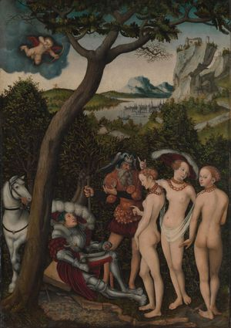
Lucas Cranach the Elder: The Judgment of Paris
The Judgment of Paris, oil on beech by Lucas Cranach the Elder, c. 1528; in the Metropolitan Museum of Art, New York City.
Myths about the gods described their births, victories over monsters or rivals, love affairs, special powers, or connections with a cultic site or ritual. As these powers tended to be wide, the myths of many gods were correspondingly complex. Thus, the Homeric Hymns to Demeter, a goddess of agriculture, and to the Delian and Pythian Apollo describe how these deities came to be associated with sites at Eleusis, Delos, and Delphi, respectively. Similarly, myths about Athena, the patroness of Athens, tend to emphasize the goddess’s love of war and her affection for heroes and the city of Athens, and those concerning Hermes (the messenger of the gods), Aphrodite (goddess of love), or Dionysus describe Hermes’ proclivities as a god of thieves, Aphrodite’s lovemaking, and Dionysus’s association with wine, frenzy, miracles, and even ritual death. Poseidon (God of the sea) was unusually atavistic in that his union with Earth, and his equine adventures appear to hark back to his pre-marine status as a horse or earthquake god.
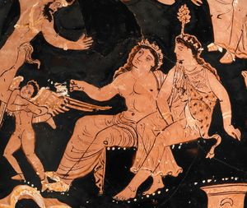
Dionysus and Ariadne with an Eros figure
Dionysus and Ariadne with an Eros figure, fragmentary Apulian red-figure pelike, terra-cotta from Apulia, Italy, about 360–350 bce.
Many myths are treated as trivial and lighthearted, but this judgment rests on the suppressed premise that any divine behaviour that seems inappropriate for a major religion must have seemed absurd and fictitious to the Greeks. Homer barely mentions the judgment of Paris, but he knew the far from trivial consequences for Troy of the favour of Aphrodite and the bitter enmity of Hera and Athena, which the “judgment of Paris” was composed to explain.
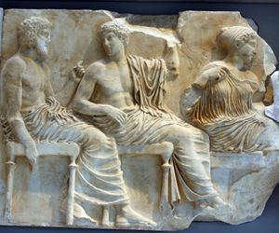
Parthenon frieze with Poseidon, Apollo, and Artemis
(From left) Poseidon, Apollo, and Artemis, marble relief, portion of the east section of the Parthenon frieze, 442–438 bce; in the Acropolis Museum, Athens.
As time went on, an accretion of minor myths continued to supplement the older and more authentic ones. Thus, the loves of Apollo, virtually ignored by Homer and Hesiod, explained why the bay (or laurel) became Apollo’s sacred tree and how he came to father Asclepius, a healing god. Similarly, the presence of the cuckoo on Hera’s sceptre at Hermione or the invention of the panpipe were explained by fables. Such etiological myths proliferated during the Hellenistic era, though in the earlier periods genuine examples are harder to detect.
Of folk deities, the nymphs (nature goddesses) personified nature or the life in water or trees and were said to punish unfaithful lovers. Water nymphs (Naiads) were reputed to drown those with whom they fell in love, such as Hylas, a companion of Heracles. Even the gentle Muses (goddesses of the arts and sciences) blinded their human rivals, such as the bard Thamyris. Satyrs (youthful folk deities with bestial features) and sileni (old and drunken folk deities) were the nymphs’ male counterparts. Like sea deities, sileni possessed secret knowledge that they would reveal only under duress. Charon, the grisly ferryman of the dead, was also a popular figure of folktale.
intercalate: insert in a calendar, insert between layers – εισάγω, παρεμβάλλω.
atavistic: relating to or characterized by reversion to something ancient or ancestral -αταβιστικός, (που επανεμφανίζεται).
proclivity: inclination, tendency – τάση.
hark back (to): return to, remember.
equine: relating to or affecting horses or other members of the horse family.
premise: a previous statement or proposition from which another is inferred or follows as a conclusion – e.g., "if the premise is true, then the conclusion must be true".
frieze: διάζωμα, ζωφόρος.
proliferate: πολλαπλασιάζομαι, αυξάνω, απλώνομαι.
duress: εξαναγκασμός, απειλή βίας.
grisly: abominable, appalling, ghastly, grotesque, hideous, horrid - τρομερός, φρικιαστικός, φρικαλέος, αποτροπιαστικός.
silenus (pl., sileni): chief of the satyrs and foster father to Dionysus - Σειληνός.
caduceus (pl., caducei): κηρύκειον.
The caduceus is the staff carried by Hermes in Greek mythology and consequently by Hermes Trismegistus in Greco-Egyptian mythology.
petasos: πέτασος, πλατύγυρο καπέλο (του Ερμή), συνήθως με φτερά – το καπέλο του περιηγητή/ ταξιδιώτη στην αρχαία Ελλάδα.
winged sandals: φτερωτά σανδάλια.
saga: a long story of heroic achievement, especially a medieval prose narrative in Old Norse or Old Icelandic.

Myths of heroes
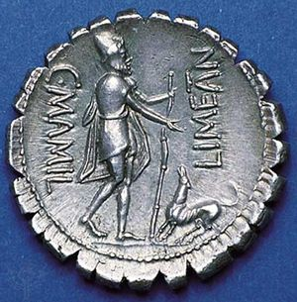
Homer: Odyssey
Reverse side of a silver denarius showing Odysseus walking with a staff and being greeted by his dog, Argus, in a narrative illustration of Homer's Odyssey. Coin was struck in the Roman Republic, 82 bce. Diameter 19 mm.

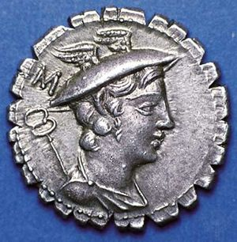
Mercury
A silver denarius showing a caduceus and bust of the Roman god Mercury wearing a winged petasos. Mercury is commonly identified with the Greek god Hermes.
Hero myths included elements from tradition, folktale, and fiction. The saga of the Argonauts, for example, is highly complex and includes elements from folktale and fiction. Episodes in the Trojan cycle, such as the departure of the Greek fleet from Aulis or Theseus’s Cretan expedition and death on Scyros, may belong to traditions dating from the Minoan-Mycenaean world. On the other hand, events described in the Iliad probably owe far more to Homer’s creative ability than to genuine tradition. Even heroes like Achilles, Hector, or Diomedes are largely fictional, though doubtlessly based on legendary prototypes. The Odyssey is the prime example of the wholesale importation of folktales into epic. All the best-known Greek hero myths, such as the labours of Heracles and the adventures of Perseus, Cadmus, Pelops, or Oedipus, depend more for their interest on folktales than on legend.

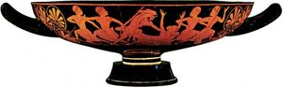
kylix showing Heracles slaying Busiris
Attic red-figure kylix by Epictetus showing Heracles slaying Busiris, c. 520 bce; in the British Museum, London.

Certain heroes—Heracles, the Dioscuri (the twins Castor and Pollux), Amphiaraus (one of the Argonauts), and Hyacinthus (a youth whom Apollo loved and accidentally killed)—may be regarded as partly legend and partly religious myth. Thus, whereas Heracles, a man of Tiryns, may originally have been a historical character, the myth of his demise on Oeta and subsequent elevation to full divinity is closely linked with a cult. In time, Heracles’ popularity was responsible for connecting his story with the Argonauts, an earlier attack on Troy, and with Theban myth. Similarly, the exploits of the Dioscuri are those of typical heroes: fighting, carrying off women, and cattle rustling. After their death they passed six months alternately beneath the Earth and in the world above, which suggests that their worship, like that of Persephone (the daughter of Zeus and Demeter), was connected with fertility or seasonal change.

Myths of seasonal renewal

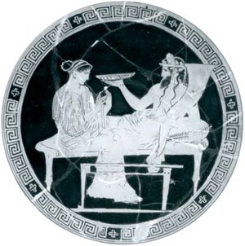
Hades and Persephone
Hades and Persephone in the underworld, interior of a red-figure cup, Greek, from Vulci, c. 430 bce; in the British Museum.
Certain myths, in which goddesses or heroes were temporarily incarcerated in the underworld, were allegories of seasonal renewal. Perhaps the best-known myth of this type is the one that tells how Hades (Latin Pluto), the god of the underworld, carried Persephone off to be his consort, causing her mother, Demeter, the goddess of grain, to allow the earth to grow barren out of her grief. Because of her mother’s grief, Zeus permitted Persephone to spend four months of the year in the house of Hades and eight in the light of day. In less benign climates, she was said to spend six months of the year in each. Some scholars hold that Persephone’s time belowground represents the summer months, when Greek fields are parched and bare, but the Hymn to Demeter, the earliest source for the myth, states explicitly that Persephone returns when the spring flowers are flourishing (line 401). Myths of seasonal renewal, in which the deity dies and returns to life at particular times of the year, are plentiful. An important Greek example is the Cretan Zeus, mentioned above.

Myths involving animal transformations
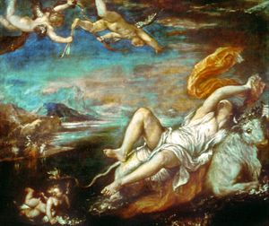
Titian: The Rape of Europa
The Rape of Europa, oil on canvas by Titian, 1560–62; in the Isabella Stewart Gardner Museum, Boston. 178 × 205 cm.
Many Greek myths involve animal transformations, though there is no proof that theriolatry (animal worship) was ever practiced by the Greeks. Gods sometimes assumed the form of beasts in order to deceive goddesses or women. Zeus, for example, assumed the form of a bull when he carried off Europa, a Phoenician princess, and he appeared in the guise of a swan in order to attract Leda, wife of a king of Sparta. Poseidon took the shape of a stallion to beget the wonder horses Arion and Pegasus.
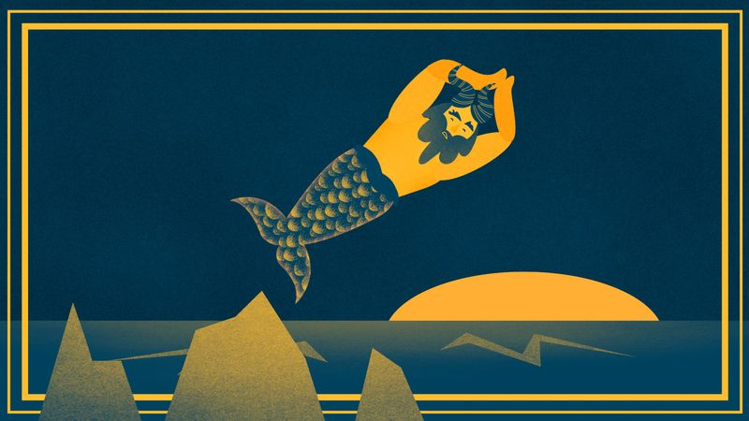
Behind the zodiac sign: Capricorn
Capricorn governs from about December 22 to about January 19.
See all videos for this article
These myths do not suggest theriolatry. No worship is offered to the deity concerned. The animals serve other purposes in the narratives. Bulls were the most powerful animals known to the Greeks and may have been worshipped in the remote past. But, for the Greeks, in even the earliest sources there is no indication that Zeus or Poseidon were once bulls or horses or that Hera was ever “ox-eyed” other than metaphorically or that “gray-eyed” Athena was ever “owl-faced.”

Other types
Other types of myth exemplified the belief that the gods sometimes appeared on Earth disguised as men and women and rewarded any help or hospitality offered them. Baucis, an old Phrygian woman, and Philemon, her husband, for example, were saved from a flood by offering hospitality to Zeus and Hermes, both of whom were in human form.
The punishment of mortals’ presumption in claiming to be the gods’ superiors, whether in musical skill or even the number of their children, is described in several myths. The gods’ jealousy of mortals’ musical talents appears in the beating and flaying of the aulos-playing satyr, Marsyas, by Athena and Apollo, as well as in the attaching of ass’s ears to King Midas for failing to appreciate the superiority of Apollo’s music to that of the god Pan. Jealousy was the motive for the slaying of Niobe’s many children, because Niobe flaunted her fecundity to the goddess Leto, who had only two offspring. Similar to such stories are the moral tales about the fate of Icarus, who flew too high on homemade wings, or the myth about Phaethon, the son of Helios, who failed to perform a task too great for him (controlling the horses of the chariot of the Sun).
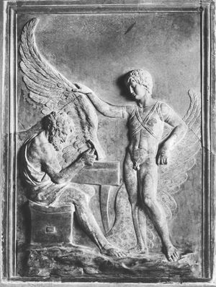
Daedalus and Icarus
Daedalus and Icarus, antique bas-relief; in the Villa Albani, Rome.
Transformation into a flower or tree—whether to escape a god’s embrace (as with Daphne, a nymph transformed into a laurel tree), as the result of an accident (as with Hyacinthus, a friend of Apollo, who was changed into a flower), or because of pride (as with the beautiful youth Narcissus, who fell in love with his own reflection and was changed into a flower)—was a familiar theme in Greek myth.
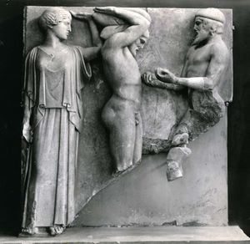
Atlas bringing Heracles the apples of the Hesperides in the presence of Athena
Atlas bringing Heracles the apples of the Hesperides in the presence of Athena, marble metope from the east end of the Temple of Zeus at Olympia, c. 460 bce; in the Archaeological Museum, Olympia, Greece.
Also popular were myths of fairylands, such as the Garden of the Hesperides (in the far west) or the land of the Hyperboreans (in the far north), or encounters with unusual creatures, such as the Centaurs, or distinctive societies, such as the Amazons.

Greek mythological characters and motifs in art and literature
Western people of all eras have been moved and baffled by the deceptive simplicity of Greek myths, and Greek mythology has had a profound effect on the development of Western civilization.
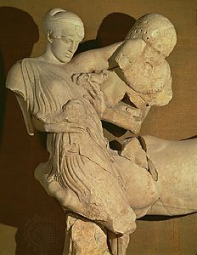
Lapith woman and Centaur
Lapith woman and Centaur, marble figures from the west pediment of the Temple of Zeus at Olympia, Greece, c. 460 bce; now in the Archaeological Museum at Olympia.

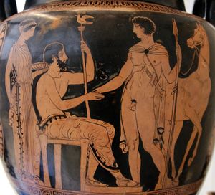
krater
Arrival or departure of a young warrior or hero;
detail of an Apulian krater, c. 410–400 bce.
The earliest visual representations of mythological characters and motifs occur in late Mycenaean and sub-Mycenaean art. Though identification is controversial, Centaurs, a siren, and even Zeus’s lover Europa have been recognized. Mythological and epic themes are also found in Geometric art of the 8th century bce, but not until the 7th century did such themes become popular in both ceramic and sculptured works. During the Classical and subsequent periods, they became commonplace. The birth of Athena was the subject of the east pediment of the Parthenon in Athens, and the legend of Pelops and of the labours of Heracles were the subjects of the corresponding pediment and the metopes (the spaces between the triglyphs on a Doric frieze) of the Temple of Zeus at Olympia. The battles of gods with Giants and of Lapiths (a mountain tribe in northern Greece) with Centaurs were also favourite motifs. Pompeian frescoes reveal realistic representations of Theseus and Ariadne, Perseus, the fall of Icarus, and the death of Pyramus.
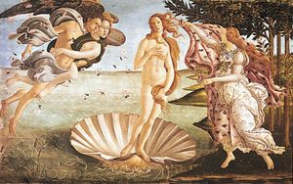
Sandro Botticelli: Birth of Venus
Birth of Venus, tempera on canvas by Sandro Botticelli, c. 1485; in the Uffizi Gallery, Florence.
The great Renaissance masters added a new dimension to Greek mythology. Among the best-known subjects of Italian artists are Sandro Botticelli’s Birth of Venus, the Ledas of Leonardo da Vinci and Michelangelo, and Raphael’s Galatea.
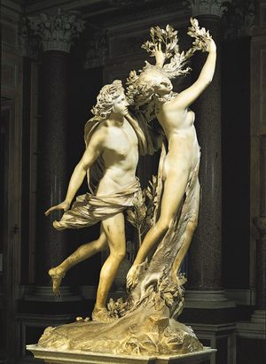
Lorenzo Bernini: Apollo and Daphne
Apollo and Daphne, marble sculpture by Lorenzo Bernini, 1622–24; in the Borghese Gallery, Rome.
Through the medium of Latin and, above all, the works of Ovid, Greek myth influenced poets such as Dante and Petrarch in Italy and Geoffrey Chaucer in England and, later, the English Elizabethans and John Milton. Jean Racine in France and Johann Wolfgang von Goethe in Germany revived Greek drama, and nearly all the major English poets from William Shakespeare to Robert Bridges turned for inspiration to Greek mythology. In later centuries, Classical themes were reinterpreted by such major dramatists as Jean Anouilh, Jean Cocteau, and Jean Giraudoux in France, Eugene O’Neill in America, and T.S. Eliot in England and by great novelists such as James Joyce (Irish) and André Gide (French). The German composers Christoph Gluck (18th century) and Richard Strauss (20th century), the German-French composer Jacques Offenbach (19th century), the Russian composer Igor Stravinsky (20th century), and many others have set Greek mythological themes to music.

Aethra
Aethra, in Greek mythology, daughter of King Pittheus of Troezen and mother of Theseus. Thinking to help fulfill the prophecy of the Oracle at Delphi regarding how the childlessness of King Aegeus of Athens would end, Pittheus (whose prospects for a son-in-law had recently vanished) plied Aegeus with wine and lured him into Aethra’s bed. When Aegeus awoke and saw where he was, he placed as birth tokens a sword and a pair of sandals under a large rock, telling Aethra that if she bore a son who could lift the rock, she should send him to Athens with the items. In some versions, such as that of the dramatist Euripides in Hippolytus, Poseidon, the god of the sea, sired Aethra’s son while the king of Athens slept. In any event, she gave birth to Theseus, who, when the time came, lifted the rock, retrieved the tokens, and went to Athens, where he would eventually succeed Aegeus as king.
Theseus and his friend Perithoos kidnapped Helen to make her Theseus’s wife. Aethra guarded her while the two men went to the underworld. Helen’s brothers, Castor and Pollux, found the two women, rescued Helen, and made Aethra her slave; they then went to Sparta. Later, when Paris took Helen to Troy, Aethra accompanied them. After the fall of Troy, Theseus’s sons, Acamos and Demophon, brought Aethra back to Athens. Aethra was often portrayed in 5th-century-BC art. Favourite scenes show her being chased by Poseidon or rescued by her grandsons.

Source: https://en.wikipedia.org/wiki/Baucis_and_Philemon

Baucis and Philemon
Baucis and Philemon (Greek: Φιλήμων και Βαυκίς, romanized: Philēmōn kai Baukis) are two characters from Greek mythology, only known to us from Ovid's Metamorphoses. Baucis and Philemon were an old married couple in the region of Tyana, which Ovid places in Phrygia, and the only ones in their town to welcome disguised gods Zeus and Hermes (in Roman mythology, Jupiter and Mercury respectively), thus embodying the pious exercise of hospitality, the ritualized guest-friendship termed xenia, or theoxenia when a god was involved.

Story
Zeus and Hermes came disguised as ordinary peasants, and began asking the people of the town for a place to sleep that night. They had been rejected by all, "so wicked were the people of that land", when at last they came to Baucis and Philemon's simple rustic cottage. Though the couple were poor, their generosity far surpassed that of their rich neighbors, among whom the gods found "doors bolted and no word of kindness".
After serving the two guests food and wine (which Ovid depicts with pleasure in the details), Baucis noticed that, although she had refilled her guest's beech wood cups many times, the pitcher was still full (from which derives the phrase "Hermes' Pitcher"). Realizing that her guests were gods, she and her husband "raised their hands in supplication and implored indulgence for their simple home and fare". Philemon thought of catching and killing the goose that guarded their house and making it into a meal, but when he went to do so, it ran to safety in Zeus's lap. Zeus said they need not slay the goose and that they should leave the town. This was because he was going to destroy the town and all those who had turned them away and not provided due hospitality. He told Baucis and Philemon to climb the mountain with him and Hermes and not to turn back until they reached the top.
After climbing to the summit ("as far as an arrow could shoot in one pull"), Baucis and Philemon looked back on their town and saw that it had been destroyed by a flood and that Zeus had turned their cottage into an ornate temple. The couple's wish to be guardians of the temple was granted. They also asked that when time came for one of them to die, that the other would die as well. Upon their death, the couple were changed into an intertwining pair of trees, an oak and a linden, standing in the deserted boggy terrain.

Analysis
The story belongs to Aarne-Thompson-Uther tale type 750.^{[1][2]} It does not appear elsewhere in ancient writings.^{[3]}

