Source: https://www.theoi.com/Khthonios/Persephone.html
Greek Mythology >> Greek Gods >> Underworld Gods >> Persephone

PERSEPHONE
Greek Name
Περσεφόνη
Transliteration
Persephonê
Roman Name
Proserpina
Translation
Destroy-Slay
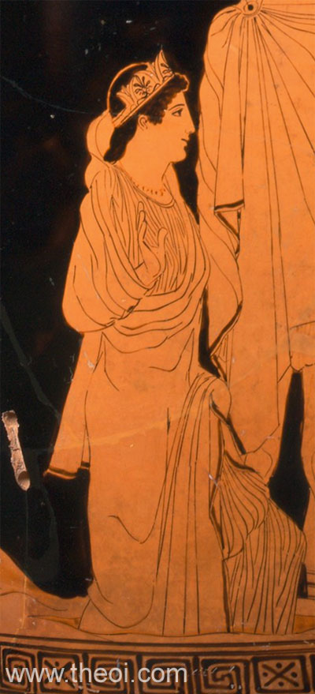

Persephone, Athenian red-figure bell krater c. 5th B.C., Metropolitan Museum of Art
PERSEPHONE was the goddess queen of the underworld, wife of the god Haides (Hades). She was also the goddess of spring growth, who was worshipped alongside her mother Demeter in the Eleusinian Mysteries. This agricultural-based cult promised its initiates passage to a blessed afterlife.
Persephone was titled Kore (Core) (the Maiden) as the goddess of spring's bounty. Once upon a time when she was playing in a flowery meadow with her Nymph companions, Kore was seized by Haides and carried off to the underworld as his bride. Her mother Demeter despaired at her disappearance and searched for her the throughout the world accompanied by the goddess Hekate (Hecate) bearing torches. When she learned that Zeus had conspired in her daughter's abduction she was furious, and refused to let the earth fruit until Persephone was returned. Zeus consented, but because the girl had tasted of the food of Haides--a handful of pomegranate seeds--she was forced to forever spend a part of the year with her husband in the underworld. Her annual return to the earth in spring was marked by the flowering of the meadows and the sudden growth of the new grain. Her return to the underworld in winter, conversely, saw the dying down of plants and the halting of growth.
In other myths, Persephone appears exclusively as the queen of the underworld, receiving the likes of Herakles and Orpheus at her court.
Persephone was usually depicted as a young goddess holding sheafs of grain and a flaming torch. Sometimes she was shown in the company of her mother Demeter, and the hero Triptolemos, the teacher of agriculture. At other times, she appears enthroned beside Haides.

In ancient Greek mythology and religion, Persephone (/pərˈsɛfəniː/ pər-SEF-ə-nee; Greek: Περσεφόνη, romanized: Persephónē, classical pronunciation: [per.se.pʰó.nɛː]), also called Kore (/ˈkɔːriː/ KOR-ee; Greek: Κόρη, romanized: Kórē, lit. 'the maiden') or Cora, is the daughter of Zeus and Demeter. She became the queen of the underworld after her abduction by her uncle Hades, the king of the underworld, who would later also take her into marriage.^{[4]}
The myth of her abduction, her sojourn in the underworld, and her cyclical return to the surface represents her functions as the embodiment of spring and the personification of vegetation, especially grain crops, which disappear into the earth when sown, sprout from the earth in spring, and are harvested when fully grown. In Classical Greek art, Persephone is invariably portrayed robed, often carrying a sheaf of grain. She may appear as a mystical divinity with a sceptre and a little box, but she was mostly represented in the process of being carried off by Hades.
Persephone, as a vegetation goddess, and her mother Demeter were the central figures of the Eleusinian Mysteries, which promised the initiated a happy afterlife. The origins of her cult are uncertain, but it was based on ancient agrarian cults of agricultural communities. In Athens, the mysteries celebrated in the month of Anthesterion were dedicated to her. The city of Locri Epizephyrii, in modern Calabria (southern Italy), was famous for its cult of Persephone, where she is a goddess of marriage and childbirth in this region.
Her name has numerous historical variants. These include Persephassa (Περσεφάσσα) and Persephatta (Περσεφάττα). In Latin, her name is rendered Proserpina. She was identified by the Romans as the Italic goddess Libera, who was conflated with Proserpina. Myths similar to Persephone's descent and return to earth also appear in the cults of male gods, including Attis, Adonis, and Osiris,^{[5]} and in Minoan Crete.

