


RESOURCE: https://www.ancient.eu/civilization/

Civilization

Definition

by Cristian Violatti
published on 04 December 2014
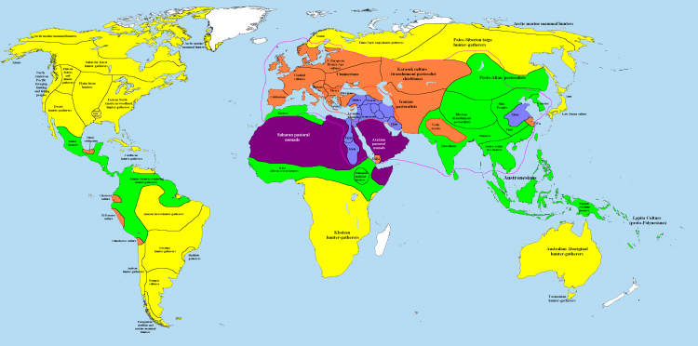
The meaning of the term civilization has changed several times during its history, and even today it is used in several ways. It is commonly used to describe human societies "with a high level of cultural and technological development", as opposed to what many consider to be less "advanced" societies. This definition, however, is unclear, subjective, and it carries with it assumptions no longer accepted by modern scholarship* on how human societies have changed during their long past.
*scholarship: academic study or achievement
Etymologically, the word civilization relates to the Latin term civitas, or ”city”, which is why it sometimes refers to urban state-level societies, setting aside the nomadic people who lack a permanent settlement and those who live in settlements that are not considered urban or do not have a state-level organization. Sometimes it can be used as a label for human societies, which have attained a specific degree of complexity. In a wide sense, civilization often means nearly the same thing as culture or even regional traditions including one or more separate states. In this sense, we sometimes speak of the “Aegean civilization”, “Chinese civilization”, “Egyptian civilization”, or “Mesoamerican civilization”, but each of these may include several cities or regions, for example: “Mesoamerican civilization” includes groups such as the Olmec, Maya, Zapotec, Aztec, and others; “Aegean civilization” includes the Minoan, Mycenaean, and other societies of the Cycladic islands and western Anatolia.
A behaviour considered "civilized" by a particular culture may be judged senseless* or even seen with horror by another culture.

*senseless: lacking common sense

Development of the term “Civilization”
During the late 19th and early 20th centuries CE, it was widely believed among European scholars that all human communities were involved in a process of straightforward progression by which the conditions of a society were gradually improving. As part of these changes, it was believed, societies experienced different stages: savagery, barbarism and, finally, civilization. Civilization, in this context, was understood as the last stop in the long journey of human society. The different stages of this social evolution were equated (=equivalent) to specific human communities: Palaeolithic and Mesolithic hunter-gatherer communities were considered part of the savagery stage, Neolithic and Bronze Age farmers as part of the barbarism stage, and finally Bronze Age urban communities (particularly those in the Near East) were considered an early phase of the civilized world. Today, this approach is no longer valid since it is linked to an attitude of cultural superiority, by which human communities which are not yet "civilized" are seen as somehow inferior.
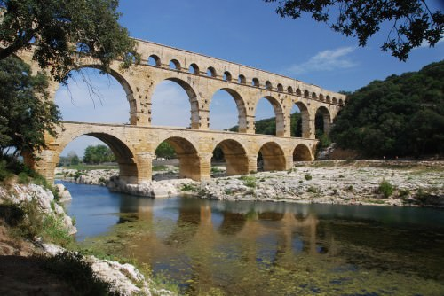
Pont Du Gard Aqueduct

Ethnocentric views
In everyday conversation, there is a tendency to use the word "civilization" to refer to a type of society that displays a set of moral values, such as respect for human rights or a compassionate attitude for the sick and the elderly. This can be problematic, since moral values are inevitably one-sided and ethnocentric. A behaviour considered "civilized" by a particular culture may be judged senseless or even seen with horror by another culture. History records an abundant number of examples of this issue. A famous one is reported by Herodotus, who describes the conflicting funerary practices of a group of Greeks, who cremated their dead, and the Indians known as the Kallatiai, who ate their dead:
During his reign, Darius summoned the Hellenes at his court and asked them how much money they would accept for eating the bodies of their dead fathers. They answered that they would not do that for any amount of money. Later Darius summoned some Indians called Kallatiai, who do eat their parents. He asked the Indians how much money they would accept to burn the bodies of their dead fathers. They responded with an outcry, ordering him to shut his mouth lest he offended the gods. Well, then, that is how people think, and so it seems to me that Pindar was right when he said in his poetry that custom is king of all (Herodotus 3.38.3-4).
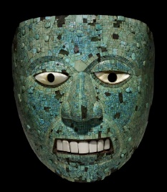
Mask of Xiuhtecuhtli

ATTRIBUTES OF A CIVILIZATION
An influential scholar named Gordon Childe identified a list of ten attributes that distinguish a civilization from other kind of societies; his list was reviewed and rewritten many times. What follows is the version of Charles Redman, an American archaeologist:
Primary characteristics
1. Urban settlements
2. Full-time specialists not involved in agricultural activities
3. Concentration of surplus production (πλεόνασμα)
4. Class structure
5. State-level organization (government)
Secondary characteristics
6. Monumental public building
7. Extensive trading networks
8. Standardized monumental artwork
9. Writing
10. Development of exact sciences
Today it is acknowledged that these criteria can be problematic for a number of reasons, mainly because the archaeological criteria used to define a civilization are not always clear-cut: reality is indifferent to our intellectual distinctions. We know of complex civilizations like the Incas, who did not have a writing system. We know of societies, which produced monumental buildings, like in the Eastern Islands or Stonehenge, where neither state-level organization nor writing existed; and we even know of urban centres, like the Preceramic Civilization in the Andes (c. 3000-1800 BCE) long before the time of the Incas, which were established before the development of extensive agriculture.
This list, however, offers a framework by which the attributes of any society can be objectively compared. If a society displays most of these attributes (or even all of them), it will enable us to refer to it as a civilization no matter how alien, unpleasant, or archaic we might find its way of life and values.

Rosetta Stone
Up until 1970’s CE, the explanations accounting for how civilizations developed tended to be monocausal, and civilizations were considered an inevitable end product (the final result/ τελικό προϊόν) of social or political evolution. Today, it is acknowledged that multi-causal explanations are likely to better explain the development of civilizations: we know that many of the social forces that in the past were believed to inevitably lead to the development of cities and states (such as long distance trade, irrigation systems, or population increase) do not always lead to that result. The diversity of human experience seems too complex and vast for our concepts to fit reality perfectly. It might be wiser, and perhaps closer to the truth, to realize that each human society is shaped by its own unique set of circumstances, and that universal explanations or general concepts do not always make perfect sense. Only if we keep these limitations in mind, the concept of civilization gains strength and becomes a useful conceptual (νοητικός, εννοιολογικός) tool.

Learn More
Related Articles Books Bibliography Cite This Work License

About the Author

Cristian Violatti
Cristian Violatti is an independent author, public speaker, and former editor of Ancient History Encyclopedia with a passion for archaeology and ancient history.

