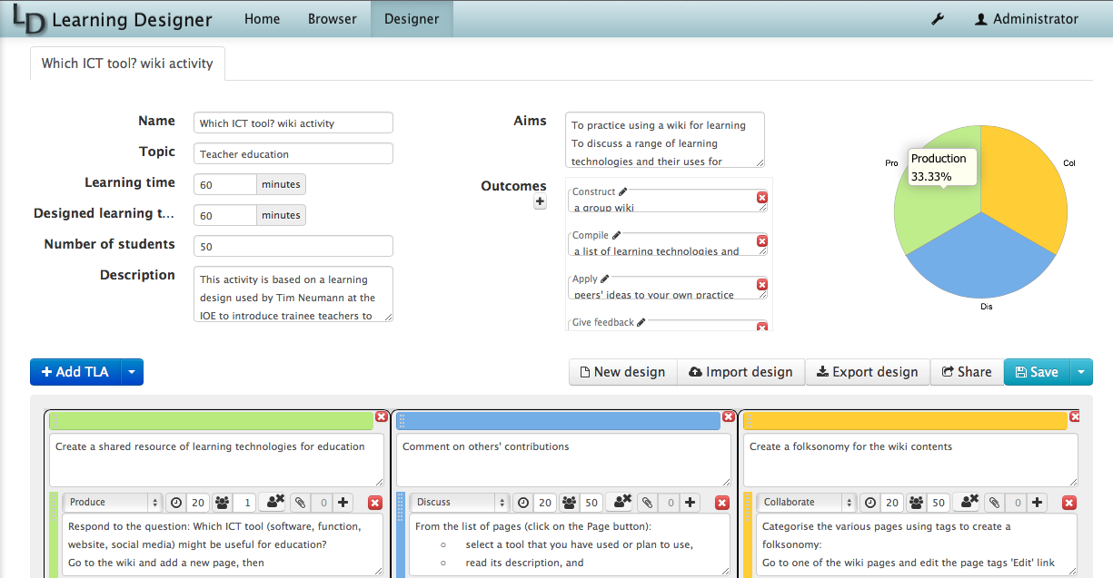
The Learning Designer

What is the Learning Designer?
The Learning Designer is web-based tool to help in the creation and sharing of learning designs (e.g. lesson plans) and to support the integration of learning technology. A learning design is displayed as the sequence of activities you have created, similar to a lesson plan, and shows all its main properties you have designed in, such as topic, number of students, aims, outcomes, duration of the learning time and the type of learning involved. Since the tool is online, you can choose to share your learning designs with your colleagues, and view and adapt learning designs that have been shared by others. You can find the tool at learningdesigner.org.

Where can I find out how to use the Learning Designer?
We have created a video guide to the Learning Designer that you can view on the LearningDesignerCommunity YouTube channel along with a further playlist of video tutorials. You can find the introductory video at Step 1.12 of Week 1 of Blended Learning Essentials: Embedding Practice, our MOOC created for the Vocational Education and Training sector.

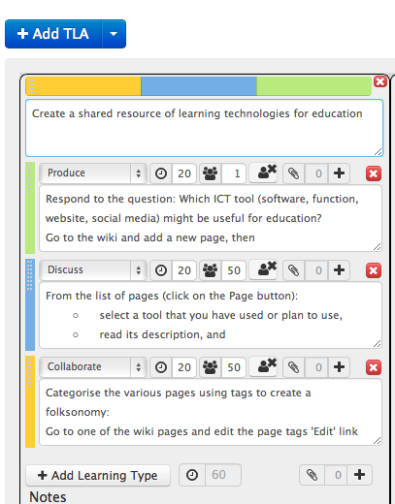
How can the Learning Designer be used in learning and teaching?
The Learning Designer helps you design learning experiences as sequences of teaching and learning activities (TLAs) that will help your learners move towards their learning goals. The Learning Designer invites you to specify your teaching aims and outcomes, which you can categorise according to Bloom’s (1956) taxonomy of educational objectives. The Learning Designer then supports you in designing the teaching and learning activities that will enable learners to meet those outcomes.
The Learning Designer prompts you to select from a drop-down list of six learning types that best describes each activity you create: is it learning from acquisition (Read/Watch/Listen)? Learning from inquiry? Learning from practice? Learning from production? Learning from discussion? Or learning from collaboration?
These learning types are drawn from Laurillard’s “Conversational Framework” (2012) – a model of what the teacher needs to put in place for learners to learn. Laurillard (2012) argues that learning requires cycles of communication to take place between teachers and learners, and learners and their peers, and that these are promoted by the combination of the six learning types.
The Learning Designer then asks you to specify the group size and how long each activity is meant to last, even if it is something the learner is doing at home, or online. This helps you take account of the entire learning experience, not just what happens when the tutor is present.
The Learning Designer will add up the learning time as you work, so you can check you are not asking the learners to do too much, which is critical to maintaining their motivation.

Analysing learning
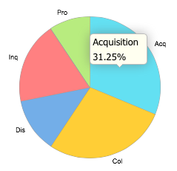
The Learning Designer creates a dynamic pie-chart showing the nature of the overall learning experience you have created so you can see at a glance whether or not this is the type of overall learning experience you feel is appropriate.
You can then make adjustments in just a few clicks e.g. change the type of learning and activity description, change the amount of time on an activity, change the group size, add a different resource, or even move the activity to a different TLA. This supports the well-established iterative reflective design approach used across all areas of education and training.

Using technology effectively
The Learning Designer supports the effective use of technology in teaching and learning by helping you make explicit what kind of learning is required. The learning type identified helps you decide which tool would be most appropriate to use. For example, tools such as wikis or shared documents can be used to facilitate collaboration and production, while ‘forums’ or the ‘comment’ function in blogs can facilitate discussion.
The Learning Designer enables you to attach links to digital tools or Open Educational Resources (OERs) anywhere on the web. For example, a presentation on SlideShare could be attached to a Read/Watch/Listen activity; a curation tool such as Scoop.it! could be attached to an Investigation activity; a Google Doc could be attached to a Production activity.

Sharing designs
The Learning Designer helps build community knowledge in effective teaching practice by allowing teachers to share their best ideas with other teachers. Each user of the Learning Designer has their own Personal Space where your designs are saved. You can choose to move your designs into your Public Space so that others can see them. You can share your learning designs with your colleagues and learners even if they are not logged into the Learning Designer by sending them a link and the tool will provide a shortened url if you click on the share icon in the Designer view. You can also export your learning design as a MS Word document for editing, printing or sharing.
You can also borrow from others, by using the Browser screen to find designs of interest to you. When you click on one, it opens in the Designer, where you can inspect it, or click “Turn editing on” to adapt it for your own context.

