|  |
| --- |
|  |
| |  |  |  |  |  |  |  |  |  |  |  |  |  |  |  |  |  |  |  |  |  |  |  |  |  |  | | --- | --- | --- | --- | --- | --- | --- | --- | --- | --- | --- | --- | --- | --- | --- | --- | --- | --- | --- | --- | --- | --- | --- | --- | --- | --- | | |  |  |  |  |  | | --- | --- | --- | --- | --- | | |  |  |  |  | | --- | --- | --- | --- | |  |  | Table of Contents |  | | | 1. [Introduction](http://www.saa.org/LinkClick.aspx?link=1344&tabid=953) 2. [Understanding the Past](http://www.saa.org/LinkClick.aspx?link=1345&tabid=953) 3. [What is Archaeology](http://www.saa.org/LinkClick.aspx?link=1346&tabid=953) 4. [Methods of Gathering Data](http://www.saa.org/LinkClick.aspx?link=1347&tabid=953) 5. [Archaeological Collections](http://www.saa.org/LinkClick.aspx?link=1348&tabid=953) 6. [Archaeology and the Public](http://www.saa.org/LinkClick.aspx?link=1349&tabid=953) 7. [Protecting the Past](http://www.saa.org/LinkClick.aspx?link=1350&tabid=953) 8. [Additional Resources](http://www.saa.org/LinkClick.aspx?link=1351&tabid=953)   [Lesson Plans and Activities](http://www.saa.org/LinkClick.aspx?link=954&tabid=953)  [Acknowledgments](http://www.saa.org/LinkClick.aspx?link=1352&tabid=953) | | |  |  | | --- | --- | |  |  | | | |  |  |  |  |  | | --- | --- | --- | --- | --- | | |  |  |  |  | | --- | --- | --- | --- | |  |  | **What is Archaeology?** |  | | | |  |  |  |  |  |  | | --- | --- | --- | --- | --- | --- | | |  |  |  | | --- | --- | --- | | [Introduction](http://www.saa.org/Default.aspx?TabId=1346#01) [How does archaeology help us understand history and culture?](http://www.saa.org/Default.aspx?TabId=1346#02) [Types of Archaeology](http://www.saa.org/Default.aspx?TabId=1346#03) |  | [Archaeological Sites](http://www.saa.org/Default.aspx?TabId=1346#04)  [Artifacts, Features, and Ecofacts](http://www.saa.org/Default.aspx?TabId=1346#05) [Context](http://www.saa.org/Default.aspx?TabId=1346#06)  [Resources](http://www.saa.org/Default.aspx?TabId=1346#07) |   **Introduction**  Archaeology is the study of the ancient and recent human past through material remains. It is a subfield of anthropology, the study of all human culture. From million-year-old fossilized remains of our earliest human ancestors in Africa, to 20th-century buildings in present-day New York City, archaeology analyzes the physical remains of the past in pursuit of a broad and comprehensive understanding of human culture.  **How does archaeology help us understand history and culture?**  Archaeology offers a unique perspective on human history and culture that has contributed greatly to our understanding of both the ancient and the recent past. Archaeology helps us understand, not only where and when people lived on the earth, but also why and how they have lived, examining the changes and causes of changes that have occurred in human cultures over time, seeking patterns and explanations of patterns, to explain everything from how and when people first came to inhabit the Americas, to the origins of agriculture and complex societies. Unlike history, which relies primarily upon written records and documents, to interpret great lives and events, archaeology allows us to delve far back into the time before written languages existed and to glimpse the lives of everyday people through analysis of things they made and left behind. Archaeology is the only field of study that covers all times periods and all geographic regions inhabited by humans. It has helped us to understand big topics like ancient Egyptian religion, the origins of agriculture in the Near East, colonial life in Jamestown Virginia, the lives of enslaved Africans in North America, and early Mediterranean trade routes. In addition. archaeology today can inform us about the lives of individuals, families and communities that might otherwise remain invisible.    **Types of Archaeology**  Prehistoric archaeology focuses on past cultures that did not have written language and therefore relies primarily on excavation or data recovery to reveal cultural evidence. Historical archaeology is the study of cultures that existed (and may still) during the period of recorded history--several thousands of years in parts of the Old World, but only several hundred years in the Americas. Within **historical archaeology** there are related fields of study that include classical archaeology, which generally focuses on ancient Greece and Rome and is often more closely related to the field of art history than to anthropology, and biblical archaeology, which seeks evidence and explanation for events described in the Bible and therefore is focused primarily on the Middle East. **Underwater archaeology** studies physical remains of human activity that lie beneath the surface of oceans, lakes, rivers, and wetlands. It includes maritime archaeology—the study of shipwrecks in order to understand the construction and operation of watercraft—as well as cities and harbors that are now submerged, and dwellings, agricultural, and industrial sites along rivers, bays and lakes. Some of the other specialties within archaeology include urban archaeology, industrial archaeology, and bioarchaeology. Cultural Resource Management archaeology, known as “CRM”, refers to archaeology that is conducted to comply with federal and state laws that protect archaeological sites.  **Archaeological Sites**  An archaeological site is any place where physical remains of past human activities exist. There are many, many types of archaeological sites. Prehistoric archaeological sites include permanent Native American villages or cities, stone quarries from which raw materials were obtained, rock art petroglyphs and pictographs, cemeteries, temporary campsites, and megalithic stone monuments. A site can be as small as a pile of chipped stone tools left by a prehistoric hunter who paused to sharpen a spear point, or as large and complex as the prehistoric settlements of Chaco Canyon in the American southwest, or Stonehenge in England. Historical archaeology sites can be found in areas as densely populated as New York City, or far below the surface of a river, or sea. The wide variety of historical archaeological sites studied include shipwrecks, battlefields and other military sites, slave quarters, plantations, cemeteries, mills, and factories.  **Artifacts, Features, and Ecofacts**  Even the smallest archaeological site may contain a wealth of important information. *Artifacts are objects made or used by people* that are analyzed by archaeologists to obtain information about the peoples who made and used them. *Non-portable artifacts called features* are also important sources of information on archaeological sites. Features include things like soil stains that indicate where storage pits, garbage dumps, structures, or fences once existed. *Ecofacts found on archaeological sites are natural remains such as plant and animal remains* that can help archaeologists understand diet and subsistence patterns.  **Context**  *Context in archaeology refers to the relationship that artifacts have to each other and the situation in which they are found*. Every artifact found on an archaeological site has a precisely defined location. The exact spot, where an artifact is found, is recorded before it is removed from that location. In the 1920s, when a stone spear point was found lodged between the ribs of a species of bison that went extinct at the end of the last Ice Age, settled an argument that had gone on for decades, establishing once and for all that people had inhabited North America since the late Pleistocene. It is the context or association between the bison skeleton and the artifact that proved this. When people remove an artifact without recording its precise location, the context is lost forever and the artifact has little or no scientific value. Context is what allows archaeologists to understand the relationship between artifacts on the same site, as well as how different archaeological sites are related to each other.  **Resources**   * [**The Draw-an-Archaeologist Test**](http://saa.org/public/educators/PDF/Draw_an_Archaeologist.pdf) by Dr. Susan Dixon-Renoe This activity, which helps to elicit student misconceptions about archaeology, can be used as a pre-unit activity as well as a concluding activity for an archaeology unit. * [**Myths and Misconceptions**](http://www.saa.org/education/guidelines/myths.html) Check out how much you know about what archaeologists do and don’t do! * [**Artifact Interpretation**](http://www.saa.org/PubEdu/A&PE/vol5no2/vol5no2-article5.pdf) A simple exercise that demonstrates the amount of information that the study of a single artifact – a coin – can yield about a society. * [**How is this Used?**](http://www.saa.org/PubEdu/A&PE/vol5no2/vol5no2-article6.pdf)  In this lesson students observe the form and shapes of tools of the past and make predictions about tool functions based on contemporary examples. * [**Context**](http://saa.org/public/educators/PDF/context_lesson.pdf) *(Adapted from Intrigue of the Past, Smith et. al. 1996.)*  This classroom activity uses a game and a discussion to demonstrate the importance of artifacts in context for learning about the past. * [**Archaeology and You**](http://www.saa.org/publications/ArchAndYou/)  This booklet from National Geographic Society and the Society for American Archaeology is designed to serve as a single reference about all aspects of the science of the past. Its topics range from basic definitions of archaeology, anthropology, and related disciplines to detailed glimpses at what archaeologists do and why they do it. * **Explore careers in archaeology with your students using these brochures:**  [The Path to Becoming an Archaeologist](http://www.saa.org/public/resources/SAA_PathBrochure.pdf) from the Society for American Archaeology [Underwater Archaeology and Careers in Historical Archaeology](http://www.sha.org/Publications/brochures.htm) from the Society for Historical Archaeology. |  |  | | | |  |  | | --- | --- | |  |  | | | |

**SOURCE:**

[What is **Archaeology**? - Society for American **Archaeology**](http://www.saa.org/Default.aspx?TabId=1346)

*http://www.saa.org/Default.aspx?TabId=1346*

How does **archaeology** help us understand history and culture? Types of **Archaeology**. **Archaeological** Sites Artifacts, Features, and Ecofacts. Context Resources

***University of Thessaly – Faculty of Humanities and Social Sciences***

***Department of History, Archaeology and Social Anthropology***

**Instructor: Anastasia-Marina G.P. Tsoutsoulopoulou**

**SOURCE: White, Nancy Marie (2008). *Archaeology for Dummies*. Wiley Publishing, Inc.**

**N.B.:** The course instructor is accountable for the following summaries from N.M. White’s book excerpts. Titles and *some* passages will be quoted *(in italics)* directly from the book.

**Summary (pp.15-19)**

**How Archaeology Became a Modern Science – Early Diggers (p.15)**

Many famous, fascinating personalities were pioneers in the development of archaeology (and models for characters like Indiana Jones).

*Historical records say that a sixth-century B.C. Babylonian king and princess were the first to dig up remains of their own society’s glorious past, restore a by-then ancient Sumerian temple-pyramid, and display artifact finds in the palace.*

*… Real archaeology is only traceable (so far) back to the Renaissance (14th through 17th centuries), when a passion for learning about the classical past developed. Wealthy folks traveled to ancient lands like Egypt and Mesopotamia and collected antiquities (old items, usually sculptures) dug out of ruins. …. Antiquarian societies and collectors accumulated loads of items and began to establish museums to display them by the 18th century.*

*Most of the knowledge of the past that people had until modern times came from historical writings or myth and legend until real science began to emerge in the Western world. The Bible told people what had happened in the past, and folktales supplied the rest.*

**Nineteenth-century archaeology (p.16)**

*By the early 1800s, naturalists and early scientists had accumulated a good body of artifacts and archaeological knowledge and were using it to interpret humanity’s past in an orderly fashion. With historical models, they charted the progress of human society through time.*

Many early archaeologists looked for adventure in searching out the remains and exquisite artifacts of the ancient past. They didn’t really “discover” various sites. It was the local people who led them there. Some good archaeologists published the information and drawings and brought back antiquities for display. However, others grabbed ancient treasures to sell for profit or display on their own estates.

**Late 19th and early 20th-century improvements (p.17)**

*The goals of archaeological pursuits became more sophisticated and scientific by the late 19th century as investigators realized they needed systematic study to make sense of the wealth of finds. Here are some notable figures of this time in archaeology’s history when more careful digging developed:*

General Pitt Rivers (southern England in the 1880s)

Sir Flinders Petrie (Egyptian pyramids)

Sir Arthur Evans (Knossos, Crete, 1900. Minoan civilization)

Cyrus Thomas (U.S. Mississippi Valley, Native American groups)

**The early 20th century: Fabulous finds and academic advances (p.18)**

Archaeologists did more orderly excavation, and synthesis of the results became more commonplace during that period.

**Famous early figures**

**1.** *Howard Carter*, who had worked with Flinders Petrie in Egypt. He discovered the spectacular tomb of King Tut*.*

**2.** *Sir Leonard Woolley* dug in Syria in 1912, assisted by T.E. Lawrence (Lawrence of Arabia), with whom he also engaged in spy activities for the British government.

**3.** *Gertrude Bell*, an Arabic-speaking British travel writer and fascinating political figure in the Middle East, investigated Mesopotamian ruins. She was also involved in British intelligence and was instrumental in the emergence of the modern country of Iraq.

**4.** *Gertrude Caton-Thompson* worked in Egypt and then excavated at Great Zimbabwe in southern Africa in 1929. She said those ruins originated with indigenous African people.

**5.** *Sir Mortimer Wheeler* was a major British archaeologist by the 1920s. He dug sites of many kinds, from Roman towns to the famous Iron-Age hill fort Maiden Castle in southern England. Then he went to India and brought to light the ancient cities of the lost Indus Valley civilization in Pakistan.

**Archaeology gets more academic (p.19)**

*Scholars realized that their major goal should now be to organize some of the vast amounts of information that digs were providing.* V. Gordon Childe*, an Australian who delved into archaeology across Europe, produced the first major syntheses of prehistory. He talked about the processes of change in the deep human past that led to the Agricultural Revolution and the Urban Revolution – in other words, food production and later the emergence of early states.*

*In the early 20th century, lots of fossil finds that show that early humans first appeared in Africa came to light. Most of this study was not archaeological but the subject of human paleontology or paleoanthropology.*

*During the Great Depression of the 1930s, U.S. president Franklin Roosevelt began programs to bring jobs to the country, including a great deal of archaeological work, especially in the poor region of the South. Hundreds of mounds and other sites were dug, and thousands of bags of artifacts were retrieved and piles of data accumulated. By then, academic institutions were beginning to train archaeologists who could supervise workers and then synthesize the findings for major regions.*

* * * * * *

**Different Kinds of Archaeology (pp.49-50)**

1. ***Avocational and educational archaeology*.** Amateur (ερασιτεχνικός) or avocational archaeologists do it as a hobby, not as a profession. … The word *amateur* comes from the Latin for “love” – you do it because you love it, not because you’re getting paid.
2. ***Landscape archaeology*** *considers the whole integrated environment in which people lived. For this specialty, you need to know geology, landforms, biology, and ecosystems to see resources available and how people would have used, even shaped, their surroundings.* Environmental archaeology *is another term for this.*
3. ***Geoarchaeology*** *combines geology, geography, and archaeology in various ways, whether studying soils, rock formations, and landforms or remote sensing, imaging, and mapping techniques. ….*
4. ***Mortuary archaeology (****αρχαιολογία θανάτου****)*** *involves specialists who excavate human graves, often to relocate them out of the path of some new construction - or they may study different kinds of burials to learn about social organization and religion.*
5. ***Bioarchaeology*** *refers to the study of human skeletons and their contexts; it requires training in biological anthropology.*
6. ***Field archaeology*** *(going out and digging) can be contrasted with* laboratory archaeology(processing and analyzing materials and data that come in from the dig), *but most professionals and amateurs do both.*
7. ***Theoretical archaeology*** *means figuring out what happened in the past by using particular models and assumptions about how humans behave at a general level. .… Different types of theories include* cognitive archaeology (humanistic, dealing with how people thought in the past), processual archaeology (scientific), and culture history (descriptive).
8. ***Ethnoarchaeology*** *(studying living cultures and their material stuff) and* experimental archaeology(replicating past artifacts yourself) *are two techniques used to help interpret what you’re digging up.*
9. ***Biblical archaeology*** *looks for evidence in the ground to support the historic record of the Bible, both Old and New Testaments. So, it’s a particular form of* historical archaeology*.*
10. ***Archaeoastronomy*** *studies how past peoples related with the sky, including aligning monuments with the sun, moon, or planets and using astronomical knowledge for religious or other purposes.****\****
11. ***Garbology (****απορριματολογία, μελέτη απορριμάτων****)*** *is a term for the archaeology of our very modern trash, as collected weekly from our homes or deposited in landfills (χωματερές).*

*It can tells us things about ourselves - consumer behavior, waste, biodegradability (***βιοδιασπασιμότητα, βιοαποδομησιμότητα***) that we can’t get anywhere else.*

**Special Studies Related to Archaeology (p.51)**

1. *Zooarchaeology:* Animal remains
2. *Paleoethnobotany:* Plant remains
3. *Archaeometry:* Archaeological sciences (and techniques)Bottom of Form

***\****Αντικείμενο της αρχαιοαστρονομίας είναι η μελέτη των [αστρονομικών](https://el.wikipedia.org/wiki/%CE%91%CF%83%CF%84%CF%81%CE%BF%CE%BD%CE%BF%CE%BC%CE%AF%CE%B1) πρακτικών, της ουράνιας γνώσης, των [μυθολογιών](https://el.wikipedia.org/wiki/%CE%9C%CF%85%CE%B8%CE%BF%CE%BB%CE%BF%CE%B3%CE%AF%CE%B1), των [θρησκειών](https://el.wikipedia.org/wiki/%CE%98%CF%81%CE%B7%CF%83%CE%BA%CE%B5%CE%AF%CE%B1) και των κοσμολογικών πεποιθήσεων σε όλους τους αρχαίους πολιτισμούς, ουσιαστικά του ρόλου που έπαιξε η αστρονομία και οι αστρονόμοι στη διαμόρφωση γηγενών πολιτισμών. Ουσιαστικά η αρχαιοαστρονομία περιγράφεται καλύτερα ως "[ανθρωπολογία](https://el.wikipedia.org/wiki/%CE%91%CE%BD%CE%B8%CF%81%CF%89%CF%80%CE%BF%CE%BB%CE%BF%CE%B3%CE%AF%CE%B1) της αστρονομίας", προκειμένου να διακρίνεται από την "[ιστορία](https://el.wikipedia.org/wiki/%CE%99%CF%83%CF%84%CE%BF%CF%81%CE%AF%CE%B1) της αστρονομίας".

***\****Archaeoastronomy is the study of astronomy practices, of celestine particulars (details, data, information, gnosis, knowledge), mythologies, religions and cosmological beliefs in all ancient civilizations – basically, the role astronomy and astronomers played in the shaping of autochthonous (indigenous) cultures. Archaeoastronomy is better defined as “anthropology of astronomy”, so it is distinguished from the ‘history of astronomy’.

**Ανθρωπολογία της αστρονομίας**

Πολλά από τα μεγάλα μνημεία και τελετουργικά οικοδομήματα των αρχαίων πολιτισμών ήταν αστρονομικά προσανατολισμένα. Ο ακριβής προσανατολισμός της μεγάλης [πυραμίδας της Γκίζας](https://el.wikipedia.org/wiki/%CE%A0%CF%85%CF%81%CE%B1%CE%BC%CE%AF%CE%B4%CE%B5%CF%82_%CF%84%CE%B7%CF%82_%CE%93%CE%BA%CE%AF%CE%B6%CE%B1) στην [Αίγυπτο](https://el.wikipedia.org/wiki/%CE%91%CF%81%CF%87%CE%B1%CE%AF%CE%B1_%CE%91%CE%AF%CE%B3%CF%85%CF%80%CF%84%CE%BF%CF%82) ή η ευθυγράμμιση προς την [Αφροδίτη](https://el.wikipedia.org/wiki/%CE%91%CF%86%CF%81%CE%BF%CE%B4%CE%AF%CF%84%CE%B7_(%CF%80%CE%BB%CE%B1%CE%BD%CE%AE%CF%84%CE%B7%CF%82)) του ανακτόρου του κυβερνήτη του Ουξμάλ στο Γιουκατάν είναι σημαντικά παραδείγματα. Μαθαίνουμε πολλά για την ανάπτυξη της [επιστήμης](https://el.wikipedia.org/wiki/%CE%95%CF%80%CE%B9%CF%83%CF%84%CE%AE%CE%BC%CE%B7) και της κοσμολογικής σκέψης από τη μελέτη τόσο των αρχαίων αστρονομικών πεποιθήσεων όσο και από τις επιζούσες γηγενείς παραδόσεις σε όλο τον κόσμο.

Με τις ρίζες τους να αναζητούνται στις ανακαλύψεις του [Στόουνχεντζ](https://el.wikipedia.org/wiki/%CE%A3%CF%84%CF%8C%CE%BF%CF%85%CE%BD%CF%87%CE%B5%CE%BD%CF%84%CE%B6) στη δεκαετία του [1960](https://el.wikipedia.org/wiki/1960), η αρχαιοαστρονομία και η εθνοαστρονομία (η μελέτη των σύγχρονων γηγενών αστρονομικών δοξασιών) έγιναν ενεργά διεπιστημονικά πεδία γνώσης που παρέχουν νέες προοπτικές για την ιστορία της αλληλεπίδρασης του είδους μας με τον κόσμο. Σφραγίδα τούτης της νέας έρευνας είναι η ενεργός συνεργασία μεταξύ επαγγελματιών και ερασιτεχνών από πολλούς κλάδους και πολιτισμούς. Το όφελος αυτής της συνεργασίας είναι ότι η αρχαιοαστρονομία επεκτάθηκε, ώστε να συμπεριλαμβάνει πληροφορίες για τα αρχαία και γηγενή ημερολογιακά συστήματα, τις έννοιες του [χρόνου](https://el.wikipedia.org/wiki/%CE%A7%CF%81%CF%8C%CE%BD%CE%BF%CF%82) και του [χώρου](https://el.wikipedia.org/wiki/%CE%A7%CF%8E%CF%81%CE%BF%CF%82), τα [μαθηματικά](https://el.wikipedia.org/wiki/%CE%9C%CE%B1%CE%B8%CE%B7%CE%BC%CE%B1%CF%84%CE%B9%CE%BA%CE%AC), τα υπολογιστικά συστήματα και τη [γεωμετρία](https://el.wikipedia.org/wiki/%CE%93%CE%B5%CF%89%CE%BC%CE%B5%CF%84%CF%81%CE%AF%CE%B1), τις τεχνικές της [ναυσιπλοΐας](https://el.wikipedia.org/wiki/%CE%9D%CE%B1%CF%85%CF%83%CE%B9%CF%80%CE%BB%CE%BF%CE%90%CE%B1), όπως επίσης τη [γεωμαντεία](https://el.wikipedia.org/w/index.php?title=%CE%93%CE%B5%CF%89%CE%BC%CE%B1%CE%BD%CF%84%CE%B5%CE%AF%CE%B1&action=edit&redlink=1) και τις απαρχές του [αστικού σχεδιασμού](https://el.wikipedia.org/wiki/%CE%91%CF%83%CF%84%CE%B9%CE%BA%CF%8C%CF%82_%CF%83%CF%87%CE%B5%CE%B4%CE%B9%CE%B1%CF%83%CE%BC%CF%8C%CF%82).

**Web**:

1. **The Excavation Process: How we excavate**

<https://www.youtube.com/watch?v=PcT1vGyJzyg>

1. **Sir Flinders Petrie – ‘father of archaeology’**

<https://www.youtube.com/watch?v=NTQxJ0HXiAo>

# **Inside the Archaeology Lab: Washing Artifacts**

<https://www.youtube.com/watch?v=xLlJXYKDx-Y>

**RESOURCE: White, N.M. (2008). *Archaeology for Dummies*. Wiley Publishing, Inc.**

**PART II: Archaeological Fieldwork: The Adventure Begins!**

**Fun picture with archaeologists working on the field and text –**

**“The 5th Wave” by: Rich Tennant:**

**One Archaeologist to another:**

**“Okay, enlarge the chicken bone by 900 percent and attach it to an e-mail to the museum saying, “Getting close … send more money.”**

**(p. 66)**

**Author’s note:**

***In this part …***

The heart and soul of archaeology is fieldwork. In Chapter 5, I get you ready by spelling out the equipment and knowledge you need. Chapter 6 describes how to find sites and know where to dig. In Chapter 7, I ask and answer questions about why you’re digging in the first place before delving into* the logistics* and daily labor of excavation. Finally, Chapter 8 explores archaeological ethics in the field.

* delve into s.th.: to examine something carefully in order to discover more information about someone or something

* logistics: planning, management, organization

**CHAPTER 5**

**Supplies and Equipment You Need**

**Summary**

**(p. 67)**

**In this Chapter**

* Filling your archaeology field pack
* Making sure you have what you need for the dig in general
* Having the right knowledge and attitude before you go

**M**any (often unusual) kinds of supplies and equipment are necessary for a proper excavation... You may have small tools, big earth-moving machines, or cases of toilet paper for the outhouse! Each fieldworker brings some items personally, and the director brings some as part of the larger inventory of excavation and recording equipment. Different projects have different requirements, depending on where you are in the world, who’s in charge, and what the field conditions are. The most important thing to bring is a mellow attitude. The dig will be much more rewarding if you take everything that happens (no matter how awful) as just part of the adventure!

**What to Pack for Fieldwork**

The field or project director usually gives you a list of what to bring. Most projects expect you to have a field pack for your own belongings, hand tools, and notebook.

**Summary**

All the stuff you bring on a dig stands a good chance of getting damaged or destroyed, so start with a good, sturdy – but perhaps not new – pack. Used military packs of heavy cotton canvas are great, though a ballistic-nylon bag in a bright color is easy to spot in the woods.

**(pp. 68-71)**

**Digging and recording supplies**

Ask what hand tools are supplied or whether you need to buy some for yourself. Here are typical excavation tools in an archaeological fieldworker’s pack:

* **Pointed 4-inch Marshalltown trowel** (and maybe a square one too)
* **3-meter measuring tape** or other small tape
* **Duct tape** (κολλητική ταινία) [*see*: White, Chapter 7, p. 105]
* **Butter knife, grapefruit or regular spoon, pocketknife, artist’s spatula and dental pick** – you might want to ask your dentist for an old or broken one, before buying one
* **Sharpened wooden chopstick or length of bamboo** for softer digging
* **Small, cheap paintbrush**
* **Roll of plastic flagging** in a bright color (a colored non-adhesive tape used in marking objects)
* **Water-resistant field notebook** (check dig requirements)
* **Compass** (πυξίδα)
* **Pencils, waterproof markers, waterproof pens, and/or space pen** (διαστημική πένα)
* **Line level** (αλφάδι) for measuring depths from a level string
* **Zipper-lock** (φερμουάρ) **plastic bags of all sizes** for finds

**Safety and health items**

All fieldwork should have safety rules, a field first-aid kit, and persons skilled in medical assistance. But bring basic supplies like aspirin or bandages. Usually archaeological projects have one or more of the following: sharp metal tools, bugs, excessive sun, poison ivy, stinging nettles, occasional bad weather, heavy physical work, and lots of dirt.

Here’s a list of items relating to health and safety that you may want to have on hand:

* **Refillable canteen** (δερμάτινο παγούρι) **or water bottle**
* **Bandages** (επίδεσμος/ dressing, covering) **and a small bottle of iodine or tube** (σωληνάριο) **of antibiotic cream**
* **Prescription medicines,** clearly labeled
* **Sunblock lotion, insect repellent and something for bites/stings**
* **Aspirin, anti-diarrheal medicine, and sore muscle liniment** (αλοιφή, λοσιόν)
* **Toilet paper and antibacterial hand cleaner**
* **Emergency food** (like a granola bar (μπάρα δημητριακών) and a small bag of peanuts)
* **Tweezers** (τσιμπιδάκι) for removing slivers (σκλήθρα, θρύμμα) and stings (κεντριά)
* **Small flashlight, waterproof matches, work gloves**

Your dig leader will probably advise getting a tetanus shot (εμβόλιο-jab) (or other immunizations) before you go. Timing is important; the tetanus shot lasts ten years, but it makes your arm sore for days, so do it early.

**Water**

Water may be provided, but you usually want your own canteen or bottle as well. Using a refillable container is better for the planet, and you may want to buy an unbreakable, insulated wide-mouth bottle with a carry strap (λουράκι/ ιμάντας μεταφοράς), on which you can write your name, so you can have cold water and even ice cubes for an emergency such as a swelling bruise (injury/ μώλωπας) or a sting. On some digs, water is scarce (rare/ σπάνιος) and so kept for drinking only, not washing.

***Living conditions***

Your living conditions depend upon the project. You may need to bring bedding for the bunkhouse (κοιτώνας, κουκέτα), a lantern (φανάρι) for the campground, or towels and soap. Avoid scented soap as it attracts bugs. Leave at home nice clothes and personal items that may be lost or damaged. For entertainment, you can bring a guitar or a paperback, if you like reading.

You can work out accommodation in advance. A small fold-up campstool is useful if you cannot sit on the ground, or a kneeling pad, to use as a cushion for your knees, may help you dig more comfortably.

***Personal needs***

Your needs and habitsdictate what other things you should bring. Include chewing gum, mints, lip balm, safety pins, wallet and ID, sunglasses, a hat, hand and/or body lotion, preferably unscented, facial tissue (χαρτομάντηλο) or handkerchiefs (μαντήλι, χαρτομάντηλο), or whatever else you carry in your purse (πορτοφόλι, τσαντάκι) or in your pockets.

***Dress requirements***

Your project will usually recommend what to wear. It depends on where you will dig, what the weather may be like, and so on. Work gloves (not the garden kind – they won’t last) are good, and a hat or a bandana to protect your hair from spider webs and branches. Long pants (rather than shorts) and sturdy (στερεός, γερός) boots with steel insteps (part of a shoe, fitting over or under the instep/ the inner arch of a foot) for shoveling (φτυάρισμα), though you can wear other sorts of footwear(s), too. Do not forget rain gear (εξοπλισμός). You may also want your camera and personal journal/diary/notebook (also labeled with your name and in waterproof containers).

If you buy new boots for a dig, break them in first by wearing them around the house or on short walks. Otherwise, your feet will hurt, which is the last thing you need during a dig.

Here is a list of items you usually should *NOT* bring:

* **Firearms, other weapons, or illegal drugs**
* **Valuables** – such as fancy jewelry
* **Perfumes or scented soaps or lotions** – they attract even more bugs
* **Nylon, polyester, or other synthetic clothing** – if you are in a hot area

***Equipment for the Survey or Dig***

Field equipment depends on the project: whether it is a *survey* – looking for sites – or excavation at one site, where you are in the world, and other conditions.

**(pp. 72-74)**

**Supplies for recording everything you find**

You want paper records even if field-rugged laptop computers and other electronic devices are available. You will probably have an official field notebook to write down how much you dig, what you find, and other information. You may draw finds on graph paper, perhaps using a protractor and ruler to get distance and angle you have measured with tape and compass.

Then you need to **fill out** (συμπληρώνω) many forms. A form for each *level* (**arbitrary** (random/ τυχαίος) vertical amount you dig – say 10 centimeters) or ***stratum*** (visible natural or cultural soil layer you dig/ στρώμα) is standard. You may also need to fill out a form to describe the ***stratigraphy*** (soil layering/ στρωματογραφία); another for features such as soil stains, house patterns, graves, or architectural fragments; and another for project photos. You list artifacts and other finds daily in a field log. Write the ***provenience*** (προέλευση)*,* the information about where each find comes from, in the **log** (βιβλίο ή αρχείο καταγραφής/ ημερολόγιο) and on the bag you put it in (using waterproof marker).

You will probably also use measuring **devices** (apparatus/ συσκευή, μηχανισμός, μηχάνημα), such as a ***transit*** ([μηχανισμός] διαμετακόμισης)*,* or electronic ***total station*** (γεωδαιτικός σταθμός/ instrument used in surveying (τοπογράφηση, επισκόπιση) and building construction) and a ***global positioning system* (GPS)** (Παγκόσμιο Σύστημα Στιγματοθέτησης) device for mapping your site. Many instruments feed data into a computer right in the field. Cameras are also important for recording.

**Supplies for digging**

You often **lay out** (σχεδιάζω) excavation units with **string** (σπάγγος, σχοινί, κορδόνι) and **stakes** (πάσσαλοι). **Shovels** (φτυάρια) and trowels have been standard digging tools for centuries. Finer tools are for uncovering delicate items. For a quick sample of what the deep oil may contain, you can use a **soil probe** (ανιχνευτής εδάφους), **coring tool** (εργαλείο γεώτρησης), or **bucket auger** (κοχλίας κάδου – auger: τρυπάνι).

**Larger equipment**

For some projects, archaeologists need larger equipment to dig. You may even use a heavy earth-moving machine, such as a **backhoe** (εκσκαφέας) or a **front-end** **loader** (φορτωτής μετωπικής φόρτωσης) to remove upper soils quickly, especially if you are trying to get down to a deeper stratum below the **topsoil** (επιφανειακό έδαφος, αρόσιμη στιβάδα). Of course, you need a careful operator who can take off a couple of centimeters at a time and top before hitting that whole ancient pot.

To find archaeological sites or find what is buried at a site without digging, you can use ***remote sensing* methods** (μέθοδοι τηλεπισκόπησης) like aerial photography, ground-penetrating radar, or metal detectors. Even if specialists with technical equipment complete these tasks, you may have to help move the instruments around. Often these tools give you a picture of some subsurface anomaly, but you still have to dig to find out what it actually is.

**Knowledge and Skills You Need**

You want to know a few things about your archaeological project before you go. What are the research goals of the fieldwork? What are the local conditions and the geography of the region like? More than anything, you want to bring along a positive attitude.

**Psychological requirements for archaeology**

You may think that working outdoors, doing manual labor, remembering so many things to write down, and living with so much dirt may not be so bad – until you get that first insect bite or sore muscle.

To appreciate an archaeological dig fully, you should be the kind of person who is tolerant of physical discomfort and the **foibles** (shortcomings, weaknesses/ αδυναμίες) of others when it is all for a good cause. Because the first exciting find – perhaps your first stone tool or piece of pottery – is usually enough to make it all worthwhile.

**CHAPTER *7:***

**The Archaeological Dig, pp. 107-108**

**Heavy earth-moving equipment**

A good equipment operator can take off very thin layers at a time and respond well to your hand directions as you walk beside the machine and look at what it is uncovering.

Usually, earth-movers are not cheap to rent. Therefore, some archaeologists buy and learn to operate their own. The following are good machines one can use for the archaeological dig.

* **Front-end loader**: this machine has an open, wide bucket to scrape off soils and pick them up or push them off to the side
* **Backhoe**: this has a narrow bucket to dig quickly very deeply and give you an idea of how deep your site’s cultural deposits extend. It usually comes on the same machine as the front-end loader.
* **Scraper pan**: it cuts off the soil in thin slices and removes it cleanly to somewhere else. The self-loading kind is the best.
* **Hydraulic excavator**: it has a telescoping arm that allows it to sit off to the side and dig without disturbing the cultural deposits. It is a good choice for small-area stripping.
* **Dragline**: it has a huge arm and can take away a lot of dirt while sitting off to the side. However, it has treads that tear up soils, so it is not that great for large sites.
* **Very small loader with backhoe bucket**: this one quickly tests sites you identify on survey to see whether they are even worth further excavation.

**!!! The following machines are not so good to use:**

* **Bulldozers with treads** (ερπύστριες) **(rather than wheels)** that gouge out (remove by digging or cutting) the soil and with so much power that they lack the control to push off thin slices of soil
* **Road graders with long vertical blades** that only level and make smooth surfaces (whether by cutting off soil or pushing soil into depressions)

**Road graders are also known as Motor graders**

**See pictures of the machines as well as short videos on how to use them**.

**e**.g. <https://www.youtube.com/watch?v=f6R7zlcSyrE>

<https://www.youtube.com/watch?v=AwGbhGwgoP0>

<https://www.youtube.com/watch?v=JpJ4Ay0ef0E>

<https://www.youtube.com/watch?v=afnJlGw7EIU>

and so on…

**depression**: λάκκος, γούβα, κοίλωμα// (καιρός) χαμηλό βαρομετρικό// (ψυχολογία) κατάθλιψη// (οικονομία) ύφεση

**grease**: γράσο, λιπαντικό

**gauge**: μετρητής, δείκτης

**dipstick**: δείκτης στάθμης λαδιού, βυθομετρική ράβδος

**wipe** (wiped): καθαρίζω

**exhaust pipe**: σωλήνας εξάτμισης

**fuel tank**: δεξαμενή καυσίμων, ντεπόζιτο

**rev:** στροφή μηχανής

**lug (**lu**gg**ing**)**: σέρνω (με κόπο)// carry or drag with great effort (machines, etc)

Whatever machinery you use, be sure to **explain to the operator** ***exactly* what you want**, as they, i.e., the operators of the machines, are used to moving lots of dirt at a time, and not little bits. Also, make certain that the teeth on the end of the bucket or blade are removed or covered.

**NATIONAL GEOGRAPHIC: ARCHAEOLOGICAL SITES**

<https://www.nationalgeographic.com/travel/article/archaeology-space-explorer>

**TEN IMPORTANT ARCHAEOLOGICAL FINDS**

[**https://www.thecompleteuniversityguide.co.uk/student-advice/what-to-study/top-ten-archaeological-discoveries**](https://www.thecompleteuniversityguide.co.uk/student-advice/what-to-study/top-ten-archaeological-discoveries)

# **Top ten archaeological discoveries**

#### Archaeological discoveries unravel secrets and challenge our ideas about human history. Here are ten discoveries that do that and more.

[Resalat Rasheed](https://www.thecompleteuniversityguide.co.uk/authors/resalat-rasheed/9425001) 03 Aug 2021

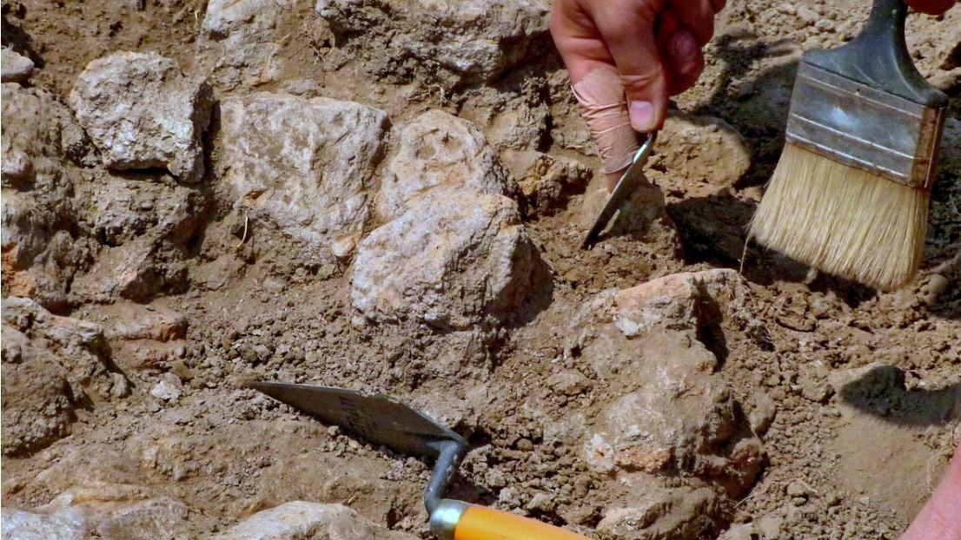

## Pompeii

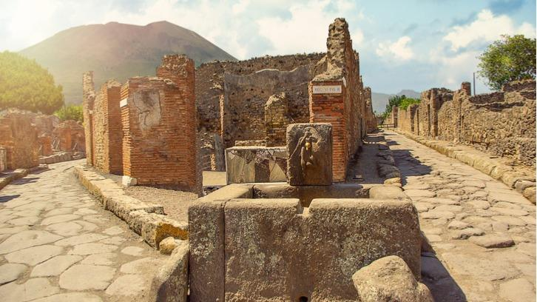

After a devastating volcanic eruption of Mt. Vesuvius in 79 AD, Pompeii – an ancient Roman city – was buried under ash and pumice. The eruption destroyed the city and killed its inhabitants, a tragic story but one that left us with a vast archaeological site and a hoard of Roman treasure.

Buried under ash means no air and moisture, so buildings, objects and cadavers have stayed well-preserved for thousands of years. A great deal of our knowledge of everyday life in a Roman city is owed to the very existence of Pompeii.

## Tutankhamun's tomb

## Tutankhamun Sarcophagus

The great Tutankhamun owes his fame to Howard Carter and George Herbert's discovery of his tomb in 1922. KV62 (the Egyptian designation for the tomb) was uncovered fairly intact in the Valley of the Kings.

Although small in size and seemingly intended for a private individual rather than royalty, the tomb contained over 2,000 pieces of valuable antiques. Tutankhamun remains a worldwide symbol and sparks renewed interest in Ancient Egypt every day. It was a great find that contributed a significant deal to archaeological awareness.

## Tutankhamun’s Treasure (Nat Geo)

## Video: <https://www.youtube.com/watch?v=-obKX-mqjXQ>

## Please watch!

## Rosetta Stone

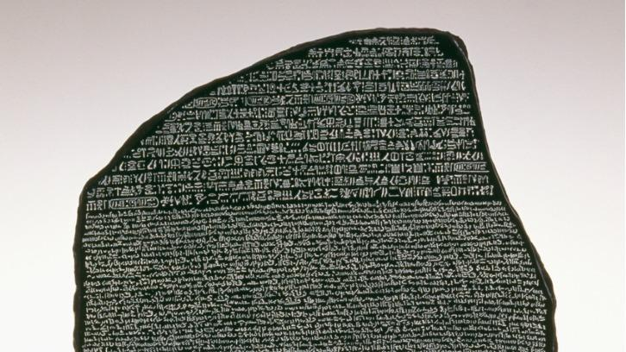

Dating back to 196 BC, the Rosetta Stone was inscribed with a decree from the Ptolemaic King Ptolemy V in three languages: Ancient Egyptian hieroglyphs, Demotic script and Ancient Greek.

Its discovery in 1799 made it the first Ancient Egyptian bilingual text uncovered in modern times. The language had previously been impossible to decipher and a bilingual find of this kind meant we could begin to make sense of hieroglyphs. We can now translate almost any artefact with Ancient Egyptian hieroglyphs thanks to the discovery of the Rosetta Stone.

## Short video: <https://www.youtube.com/watch?v=5DeKyBhPhIw>

## Hieroglyphs:

## Short video: <https://www.youtube.com/watch?v=WIjREbbFjNE>

## Terracotta Army

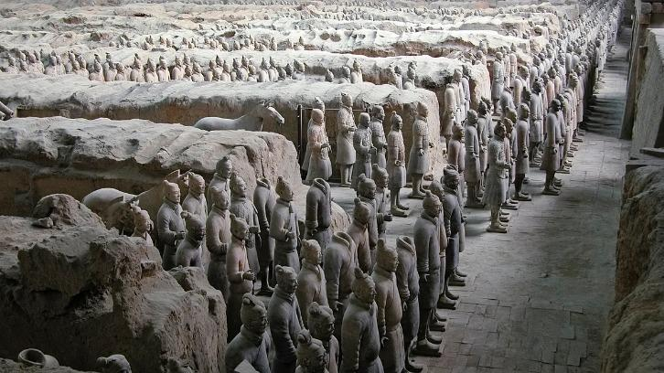

The Terracotta Army is a mesmerising collection of terracotta sculptures depicting the armies of China's first emperor, Qin Shi Huang. It’s an example of funerary art made with the symbolic intention of protecting the emperor in his afterlife.

The army dates from the third century BC and numbers approximately 8,000 soldiers, 130 chariots and 520 horses. It tells us a lot about how Chinese soldiers were equipped at the time, the weapons they used and the clothes they wore.

## Richard III's grave

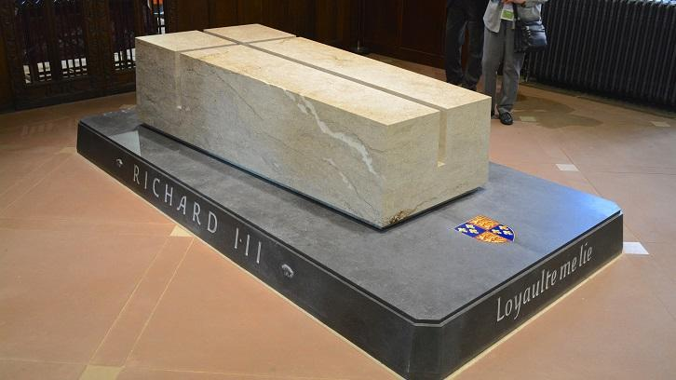

The last Plantagenet King of England, Richard III’s reputation as a prince killer, crookback, and all-round nasty power grabber is a mainstay of English folklore. Despite his infamy, his burial site remained a mystery until the Looking for Richard project in 2012.

With the help from the University of Leicester's archaeological services, the project uncovered human remains within the site of the former Greyfriars Friary Church in Leicester. The remains were tested and scientifically proven to be those of Richard III, attracting much media attention.

1. **READ MORE**
2. [Archaeology subject table](https://www.thecompleteuniversityguide.co.uk/league-tables/rankings/archaeology)
3. [Archaeology courses](https://www.thecompleteuniversityguide.co.uk/courses/search/undergraduate/archaeology)
4. [Archaeology guide](https://www.thecompleteuniversityguide.co.uk/subject-guide/archaeology)

## Olduvai Gorge

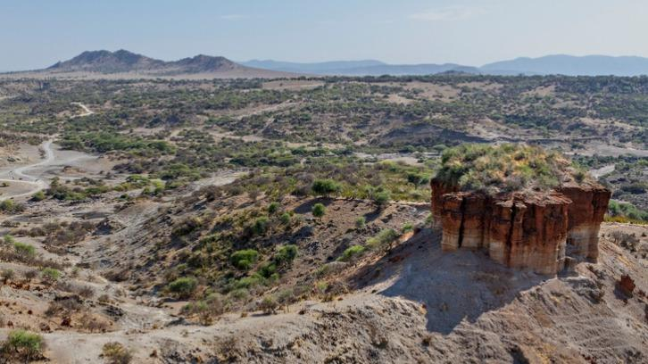

This 30-mile section of Tanzania's Rift Valley is responsible for much of what we know about the evolution of hominins and eventual existence of our species. Fossil remains found in Olduvai Gorge show that precursor human species date as far back as 1.9 million years ago.

They also show how we've increased in social and cognitive complexity through stone tool use and a hunter-gatherer lifestyle. Tools and animal remains found in a central area indicated developing social interaction and these phenomena are seen in increasing fashion in the more recent remains. Our species, homo sapiens, are thought to have occupied the site from around 17,000 years ago.

## Cave of Altamira

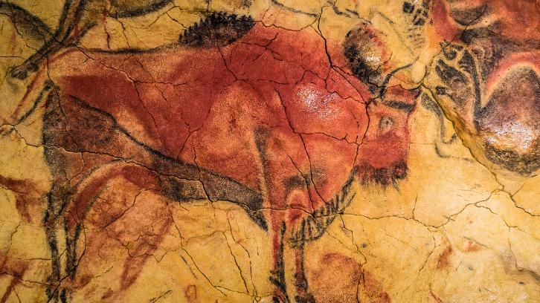

The Cave of Altamira represents a fascinating example of where the fields of archaeology and anthropology meet to tell a beautiful story. The Spanish cave contains prehistoric paintings of mammals and human hands, and when it was discovered in 1880 it was the first find of its kind.

The discovery totally changed our understanding of prehistoric humans, who were previously believed to lack the intellectual capacity for artistic expression. The artefacts date back to between 14,000 and 20,000 years ago, giving us a glimpse into the lives of our very distant ancestors.

## Dead Sea Scrolls

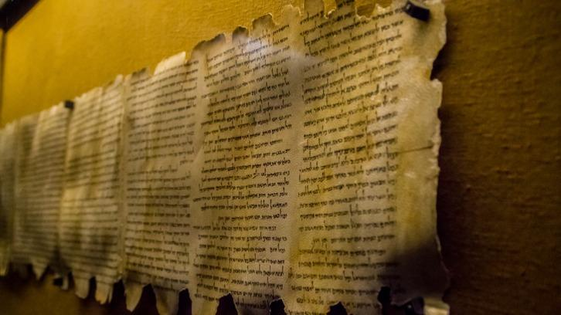

The Dead Sea Scrolls are a collection of 800 manuscripts found in 11 caves just 2km inland from the Dead Sea and in the vicinity of Khirbet Qumran, an ancient settlement in the West Bank.

The texts are some of the earliest known Hebrew biblical documents, and date over a 700-year period before the birth of Jesus Christ. They've provided incredible insight for biblical translators, shining a light on what the Bible was like 2,000 years ago and how it was put together by various individuals over many years.

## Easter Island Moai

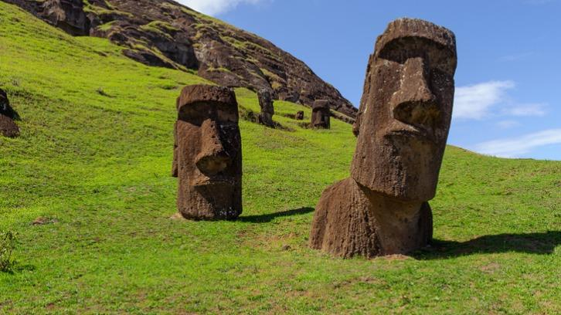

Archaeologists have recorded 887 massive statues on Easter Island, a Chilean Polynesian island in the Pacific Ocean. The statues are known as Moai, and are an impressive tribute to the Rapa Nui people dating to between 1250 and 1500.

What's so interesting about the Moai is the feat it must have taken for their transportation across the island. Legends among the Rapa Nui people recall how they used divine power to command the statues to walk.

## Staffordshire Hoard

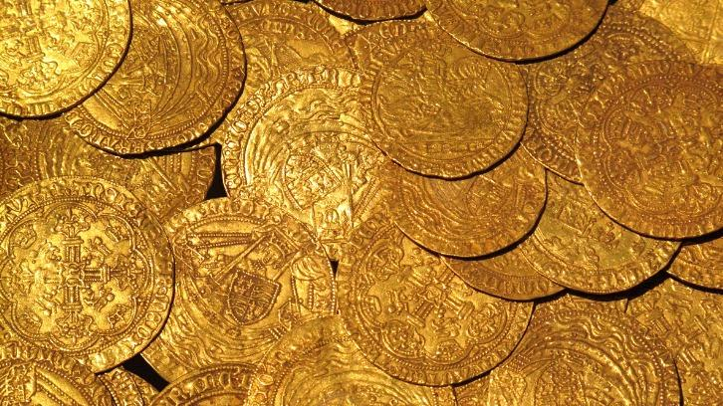

The Staffordshire Hoard represents the largest hoard of Anglo-Saxon gold and silver metalwork ever found. Consisting of over 3,500 items, the hoard was found by a metal detectorist buried underneath a farmer’s field in Staffordshire, UK, in 2009.

The discovery is said to have completely altered the perception of Anglo-Saxon England, and seeing as the hoard accounts for over 60% of all the Anglo-Saxon items we've conserved, that's not surprising. The hoard was valued at over £3 million.

**ALEXANDER THE GREAT – ARCHAEOLOGICAL SITES**

<https://www.aigai.gr/www.aigai.gr/en/learn_more/kottaridi-lady-aigai-alexander-great-treasures-epic-era-hellenism-onassis-foundation-new.html>

# **SEVEN ARCHAEOLOGICAL WONDERS OF ANCIENT INDIA**

<https://archaeology-travel.com/archaeological-sites/seven-archaeological-wonders-of-ancient-india/>